**Name:** Joseph Andrew Schnieders

**Rank and Service:** LT, United States Navy

**Thesis ID:** 30384

**Title:** COMPARISON STUDY OF LOW-LEVEL CONTROLLER TECHNIQUES FOR UNMANNED SURFACE VESSELS

**Advisor:** Dr. Brian Bingham

**Co-advisor**: N/​A

**Second reader:** Dr. Sean Kragelund

**If this is a co-authored paper, are you earning different degrees? No, No**

**Student:** Fill in the highlighted areas above.

**Thesis processor**: Insert first 8 pages here, from student’s dashboard, during   
Final Review.

TABLE OF CONTENTS

I. INTRODUCTION 1

A. MOTIVATION 1

B. PROBLEM STATEMENT 1

II. BACKGROUND 3

A. MODELS used for research USV 3

1. Introduction 3

2. Simplified Dynamic Modeling for Control 4

3. System Specification 6

B. control techniques OF INTEREST 8

1. PID 8

2. Feed-Forward 9

3. Thruster Model Selection 11

C. approach 13

1. Test Cases for Comparison 14

2. Tuning Methods Discussion 15

III. simulation results and analysis 19

A. simulation setup 19

B. MODEL VERIFICATION 21

C. decoupled dynamics 23

1. Heading Control 23

2. Speed Control 27

D. simulation SUMMARY 43

IV. experimental results and analysis 45

A. experimental setup 45

1. KF-USV Software and Controller Implementation 45

2. Sensor Integration and Feedback Management 46

3. Test Site Locations 47

4. Testing Apparatus and Associated Hardware 49

5. Environmental Considerations 52

B. experimental testing approach 52

C. Decoupled dynamics 53

1. Heading Control 53

2. Speed Control 56

D. coupled dynamics 65

E. experimental SUMMARY 70

V. CONCLUSION(S) 73

A. simulation and experimental comparison 73

B. controller technique benefits analysis 75

C. proposal for future studies 75

List of References 77

initial distribution list 81

LIST OF FIGURES

Figure 1. Step Response of a Generic Second Order System and Performance Characteristic. Source: [5]. 2

Figure 2. 6 DOF Coordinate Frame. Adapted from [8] 3

Figure 3. CLEARPATH Robotics™ KINGFISHER. Source: [8]. 7

Figure 4. Generalized PID Feedback Loop. Adapted from [13]. 9

Figure 5. Generalized Command-Compensated Control Loop. Source: [15] 10

Figure 6. Simplified Feed-Forward Control Model for USV 11

Figure 7. Thrust Command Relation. Source: [10] 13

Figure 8. Complete Simulation Model—Top Layer 19

Figure 9. PID Controller—Sub-Layer 20

Figure 10. USV Simulation Model—Sub-Layer 20

Figure 11. USV Equations of Motion—Sub-Layer 21

Figure 12. Model Verification Results 22

Figure 13. Open-Loop USV Model 23

Figure 14. Tuning Step Responses—Heading Control—Linear Thrust Model Approximation 24

Figure 15. Tuning Step Responses—Heading Control—Non-Linear Thrust Model Approximation 25

Figure 16. Heading Control—Optimized Step Response—Linear and Non-Linear Thrust Model Approximations 27

Figure 17. Tuning Step Responses—Low-Speed—Linear Thrust Model Approximation 29

Figure 18. Tuning Step-Responses—Low Speed Control—Non-Linear Thrust Model Approximation 29

Figure 19. Optimized Step Responses—Low-Speed Control—Linear and Non-Linear Thrust Model Approximations 31

Figure 20. Speed Control with Feed-Forward Architecture in Simulink Model 32

Figure 21. Tuning Step Responses—Low-Speed Control without Feed-Forward Compensation 33

Figure 22. Tuning Step Responses—Low-Speed Control with Feed-Forward Compensation 34

Figure 23. Optimized Step Response—Low-Speed Control—Feed Forward Control 35

Figure 24. Optimized System Response—Feed-Forward Compensation—Integrator Effort Comparison 36

Figure 25. Tuning Step Responses—High-Speed—Linear Thrust Model Approximation 37

Figure 26. Tuning Step-Responses—High Speed Control—Non-Linear Thrust Model Approximation 37

Figure 27. Tuning Step-Response—High-Speed Control—Second Gain Testing Iteration 38

Figure 28. Optimized Step-Response—High-Speed—Linear and Non-Linear Thrust Model Approximations 39

Figure 29. Tuning Step Responses—High-Speed Control without Feed-Forward Compensation 41

Figure 30. Tuning Step Responses—High-Speed Control with Feed-Forward Compensation 41

Figure 31. Optimized Step Response—High-Speed Control—Feed Forward Control 42

Figure 32. Optimized System Response—Feed-Forward Compensation—Integrator Effort Comparison 43

Figure 33. Simulink Model of Controller with ROS Functionality 46

Figure 34. CAVR Test Tank 48

Figure 35. Lake El Estero, Monterey, California. Adapted from [21]. 49

Figure 36. Lake El Estero Experimental Setup Overview 50

Figure 37. Lenonvo ThinkPad T460 with Logitech F310 Gamepad USB Controller. 51

Figure 38. CLEARPATH Wireless Router and Tripod. 51

Figure 39. Experimental Heading Control – Oscillation Error Example 54

Figure 40. Heading Control – Experimental Step Responses – Linear and Non-Linear Thrust Model Approximations 55

Figure 41. Optimized Experimental Step Responses – Low Speed Control –Linear and Non Linear Thrust Model Approximations 58

Figure 42. Optimized Step Response—Low-Speed Control—Feed Forward Control 60

Figure 43. Optimized System Response—Feed-Forward Compensation—Integrator Effort Comparison 60

Figure 44. Optimized Experimental Step Responses – High Speed Control –Linear and Non Linear Thrust Model Approximations 62

Figure 45. Optimized Step Response—High Speed Control—Feed Forward Control 64

Figure 46. Optimized Experimental Step Responses – High Speed Control – Feed Forward Control Integrator Analysis 64

Figure 47. Optimized System Response—Feed-Forward Compensation—Integrator Effort Comparison 65

Figure 48. Optimized Experimental System Responses – Low Speed Turn – Coupled Dynamics 66

Figure 49. Optimized Experimental System Response—Low Speed Turn - Compensation—Integrator Effort Comparison 67

Figure 50. Optimized Experimental System Responses – Low Speed Turn – Coupled Dynamics 69

Figure 51. Optimized Experimental System Response—Low Speed Turn - Compensation—Integrator Effort Comparison 70

LIST OF TABLES

Table 1. Model Assumptions and Justifications 6

Table 2. KF-USV System Specification 7

Table 3. Motor Command to Thruster Force Relationship 13

Table 4. Test Case Definition Matrix 14

Table 5. Ziegler-Nichols Tuning Rules 16

Table 6. Gain Constant Testing Values 17

Table 7. Model Verification Results 22

Table 8. Heading Control—Linear and Non Linear Thrust Model Approximation—Step Response Characteristic Comparison 26

Table 9. Heading Control—Optimized Controller—Step Response Characteristic Comparison 27

Table 10. Performance Characteristic Comparison—Low-Speed Control—Linear and Non Linear Thrust Model Approximation 30

Table 11. Optimized Performance Characteristics Comparison—Low-Speed Control—Linear and Non-Linear Thrust Model Approximations 31

Table 12. Performance Characteristics Comparison—Low-Speed Control—Feed Forward Compensation 33

Table 13. Optimized Performance Characteristics—Low-Speed Control—Feed-Forward Compensation 34

Table 14. High Speed Control—Refined Tuning Gain Table 38

Table 15. Optimized Performance Characteristics—High Speed—Linear and Non-Linear Thrust Model Approximations 39

Table 16. Optimized Performance Characteristics—Low-Speed Control—Feed-Forward Compensation 42

Table 17. ROS Nodes, Topics and Messages of Interest for Research 46

Table 18. Selected Weather Data from Experimental Testing Days. Source: [22] 52

Table 19. Heading Control - Experimental Results – Performance Characteristics 56

Table 20. Optimized Experimental Performance Characteristics Comparison—Low-Speed Control—Linear and Non-Linear Thrust Model Approximations 58

Table 21. Optimized Experimental Performance Characteristics—Low-Speed Control—Feed-Forward Compensation 59

Table 22. Optimized Experimental Performance Characteristics Comparison—High-Speed Control—Linear and Non-Linear Thrust Model Approximations 62

Table 23. Optimized Experimental Performance Characteristics—High-Speed Control—Feed-Forward Compensation 63

Table 24. Optimized Experimental Performance Characteristics Comparison—Coupled Dynamics – Heading Response at Low Speed 67

Table 25. Optimized Experimental Performance Characteristics Comparison—Coupled Dynamics – Heading Response at Low Speed 69

THIS PAGE INTENTIONALLY LEFT BLANK

LIST OF ACRONYMS AND ABBREVIATIONS

ASW Anti-Submarine Warfare

CAVR Center for Autonomous Vehicle Research

CUSV Common Unmanned Surface Vessel

DOF Degrees of Freedom

EOM Equations of Motion

INS Inertial Navigation System

KF-USV KINGFISHER USV

MDUSV Medium Displacement Unmanned Surface Vehicle

MIW Mine-Warfare

MRAC Model Reference Adaptive Control

OEM Original Equipment Manufacturer

PD Proportional-Derivative

PI Proportional-Integral

PID Proportional-Integral-Derivative

ROS Robotic Operating Software

SNAME Society of Naval Architects and Marine Engineers

USN United States Navy

USV Unmanned Surface Vessel

X-USV *X-class* Unmanned Surface Vessel

THIS PAGE INTENTIONALLY LEFT BLANK

ACKNOWLEDGMENTS

Saved for final draft.

THIS PAGE INTENTIONALLY LEFT BLANK

# INTRODUCTION

## MOTIVATION

The United States Navy (USN) is aggressively pursuing the automation of unmanned surface vessels (USV) to accomplish resource-intensive, long-endurance and meticulous tasks that have been historically fulfilled by manned vessels. The desired tasks are often related to missions categorized into anti-submarine warfare (ASW) and mine warfare (MIW). This includes leveraging the Defense Advance Research Project Agency’s (DARPA) medium-displacement unmanned surface vehicle (MDUSV) *Sea Hunter* to actively track submarines through vast waterspace [1] and utilizing a Common USV (CUSV) to pull minesweeping equipment through potential mined waterways [2]. These are examples of large-scale USVs but more pertinent to the following research is the Navy’s pursuance of X-classUSVs (X-USV), which are characterized as less than 3.048 meters (10 feet) and designed to fulfill missions where “stealth, modularity, expendability, light weight, and low cost are critical”[3]. Inherent to all these applicants is the need for control systems to conduct functions in the absence of manned crews. The MDUSV, CUSV, and X-USV each require low-level controllers for heading and speed execution to fulfill higher-level functions such as submarine tracking or mine hunting. The effectiveness in the response of these low-level controllers can be critical to the overall mission accomplishment by effecting their ability to carefully navigate hazardous waters, avoid navigational hazards, and/​or maintain a desired track.

## PROBLEM STATEMENT

Many different control techniques can and have been applied to a small-scale USV to maintain heading and speed. These include but are not limited to Proportional-Integral-Derivative (PID) controllers, PID with augmentations such as a feed-forward and/​or gain-scheduling, and adaptive controllers (e.g., L1, model reference adaptive control [MRAC]) [4]. Controller selection depends heavily on the degree of desired performance (i.e., accuracy and reliability) and can have constraints on computational resources, sensor integration, and previous knowledge of the system or model required for implementation. They also vary in the amount of tuning required to produce effective results. All of these factors can enable or inhibit control selection.

This research aims to objectively and subjectively compare and contrast benefits and drawbacks to a limited combination of control techniques with regards to effectiveness and tuning requirements. We will utilize performance characteristics from step responses such as rise time (Tr), settling time (Ts), percent overshoot, and steady state error (see Figure 1 for an example) generated from set point changes in speed and heading. This is then compared to predicted changes and also evaluated for consistency. In addition to the analytical comparison, there will be discussion in the differences required to tune the controllers and ultimately recommendations made in further studies.

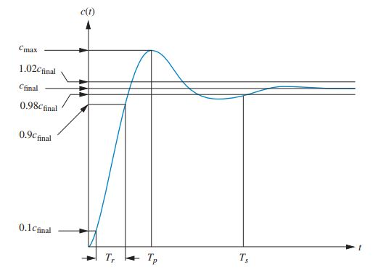

1. Step Response of a Generic Second Order System and Performance Characteristic. Source: [5].

# BACKGROUND

## MODELS used for research USV

### Introduction

In [6], [7], Fossen defines that a marine vessel can be defined by a general 6 degrees of freedom (DOF) rigid-body relative to an inertial based coordinate frame. Figure 2 provides the basis for coordinate frame and direction discussion during further analysis.

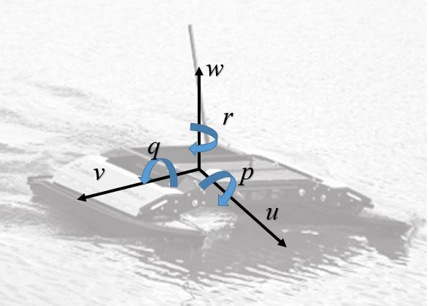

1. 6 DOF Coordinate Frame. Adapted from [8]

These 6 DOF can be mathematically reduced to a matrix-vector Equation (1) [7] utilizing the Society of Naval Architects and Marine Engineers’ (SNAME) notation [9].



where:

* *MRB* is the mass-inertia matrix
* *CRB()* is the Coriolis and centripetal matrix
* *D()* is the damping matrix
* *g()* is a generalized gravitational and buoyancy force vector
* *go* is a collection of static, ballast and restoring forces and moments.
* *τwave* and *τwind* are wind and wave external forces and moments acting on the rigid body.
* *u, v,* and *w* are the surge, sway and heave linear velocities respectively
* *p, q,* and *r* are the roll, pitch and yaw angular velocities respectively
* *x, y,* and *z* are positions of the body as related to the center of gravity.
* *ϕ, θ,* and *ψ* are Euler angles with respect to the coordinate frame of choice.
* *X, Y, Z, K, M,* and *N* are the external moments and forces.

For this research we will be designing and implementing controllers for speed as it relates to surge (***u***) and heading as it relates to yaw (**ψ**).

### Simplified Dynamic Modeling for Control

It is beneficial to simplify and resolve the resulting equations of motion (EOM) of a generalized 6 DOF model (1) in order to begin implementing simple control techniques. First, speed and heading (i.e., by steering) equations are defined by Equations (2)-(3) respectively [7], [10]. These equations include effects of inertia, Coriolis, added-mass, linear and quadratic drag, coupled drag, and monk moments. They also assume a vessel with thrust generation and a rudder or other control surface for steering.





Whereas, the USV utilized for this research has independent non-rotating port and starboard water jets that provide thrust and steering. By combining aspects from models of Fossen, Caccia, Veruggio et al., [6], [7], [11] and making the assumptions listed in Table 1, we arrive at two simplified and decoupled equations for thrust and steering (4)-(5):





where:

*  and represent the quadratic and linear drag associated with the surge direction and is the linear drag associated with turning.
* is the total control force (i.e., thrust) in the surge direction
*  is the moment of inertia about vertical axis with respect to the center of gravity
*  is the total control torque about the vertical axis.

1. Model Assumptions and Justifications

|  |  |
| --- | --- |
| **Assumption** | **Justification** |
| Uncoupled Dynamics (surge/​yaw) | For simplicity of control design. Modeling for vessels shows coupled dynamics [11] but is ignored for this research. |
| Sway (±*v*) motion is neglected | Sway motion (i.e., side-slip) not observable through previous experiments with particular USV [10]. |
| Added mass, , is neglected. | Caccia et al. [12] stated for a small catamaran vessel that this value is typically less than 5% of the vessels mass and therefore negligible. |
| Centripetal terms, , terms are neglected. | Caccia et al. [12] stated for turning rates of less than 10 degrees/​second is negligible. |

### System Specification

The vessel used for this research is a CLEARPATH Robotics™ KINGFISHER USV (KF-USV). The KF-USV is pictures in Figure 3. It is a catamaran hull form with two non-directional water jets utilized for thrust and steering. Based on testing by Manzini [10], Table 2 displays the system specifications and physical parameters of concern to our dynamic model.

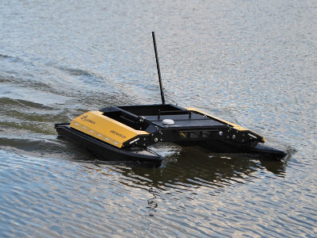

1. CLEARPATH Robotics™ KINGFISHER. Source: [8].
2. KF-USV System Specification

|  |  |
| --- | --- |
| **Specification** | **Value** |
| Mass () | 36.0 kg  Payload included |
| Moment of Inertia () | Based on thin-disk assumption |
| Quadratic surge drag () | Determined experimentally |
| Linear surge drag () |  |
| Quadratic yaw drag () | Determined experimentally |
| Linear yaw drag () |  |

## control techniques OF INTEREST

### PID

One of the most fundamental and common techniques of feedback control is the use of a Proportional-Integral-Derivative (PID) controller. Figure 4 displays a general visualized feedback loop with a PID controller operating on the error, *e*, between the output, *y*, and the desired set-point, *ysp*. Inherent to a PID controller are the three components or terms that operate on the error in different ways. The proportional terms operate as a multiplicative factor on the error. The integral term evaluates the error as a function of time and drives the steady state error between the output and set point to zero. The derivative term operates on the rate change of the error and can help in minimizing factors such as overshoot and/​or oscillation. Åstrom provides three common mathematical definitions of a PID controller which are displayed in Equations (6)-(8) [13].







Equations (6) and (7) are the textbook representations with a single gain, *K*, in the time and “s” domain respectively. Equation (8) is the form that, when implemented, a controller most closely represents with respect to *tuning*. This is because ,, andare the gains associated with the proportional, integral, and derivative terms respectively and are the proverbial *knobs* referenced when one talks about *turning the knobs* for controller tuning. This is important when it comes to the further discussion of the comparisons in tuning techniques and requirements.

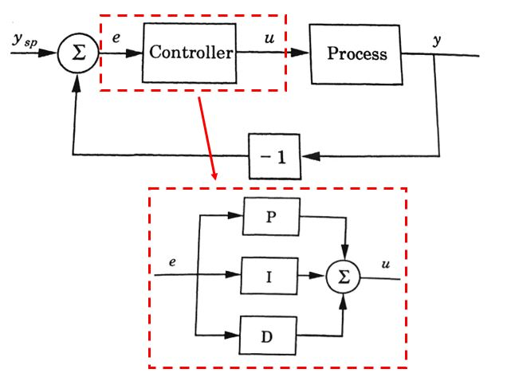

1. Generalized PID Feedback Loop. Adapted from [13].

### Feed-Forward

A phenomena associated with PID controllers is the effect of integral *wind-up*. Wind-up is caused by the requirement for increasing the integral term’s effect to the accumulation of error. Therefore, relative to the system dynamics, the integrals effect is delayed which can be undesired for certain applications. One of the common techniques to counter this is the use of a feed-forward term in control process. This terms leverages knowledge known of the system (e.g., model dynamics or system disturbances) and provides that value associated with a set point early in the control process [14]. As it relates to the integral term, and one of the research questions for this thesis is: Will an adequate feed-forward term minimize the effect of the integrator on the overall system?

Doebelin [15] proposes that there are two common techniques of feed-forward control; disturbance-compensated control and command-compensated control. Disturbance control is based on having a sensor able to detect and measure a major disturbance and developing a mathematical relation to it and the system that can be subtracted from the reference input in an open-loop configuration. Command-compensated control is the concept of utilizing a relationship of the set-point to the expected output based on empirical knowledge of the system. A generalized command-compensated control from [15] is shown in Figure 5 where *V* and *C* represent input and output, *GC* is the command-compensated term, *G11*, *G2* and *H* represent general transfer function terms in the control loop.

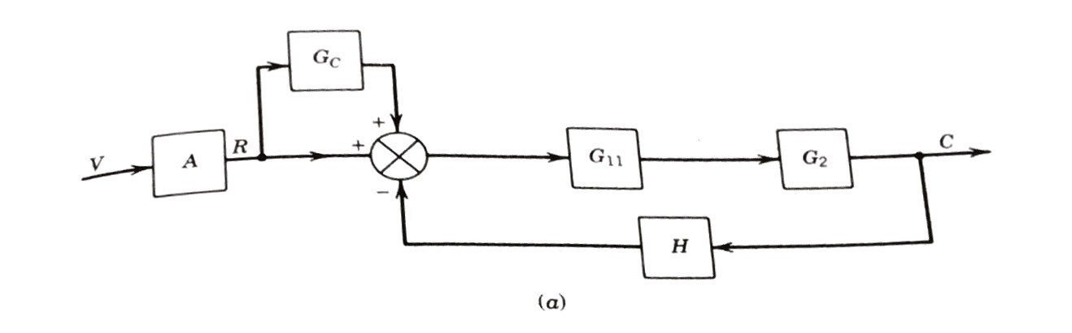

1. Generalized Command-Compensated Control Loop. Source: [15]

We will consider only command-compensated control and refer to it exclusively as feed-forward control. For this research, we utilized this concept as it applied to speed control because of the dynamics of the surge model. Assuming the simplified model from (4), we can estimate the force required at a desired speed. It is not mathematically analogous for heading because there is not a steady state force that is required to complete a certain change in direction. Figure 6 is a simplified illustration on the feed-forward control that is incorporated for this research.

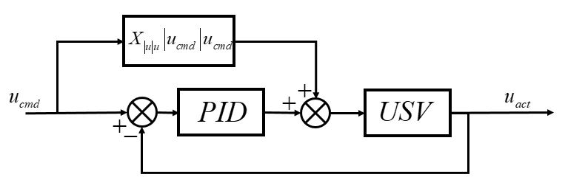

1. Simplified Feed-Forward Control Model for USV

### Thruster Model Selection

The last control technique that this research addresses is the selection of a relationship between thruster force and motor command to the USV. The thrust command to the electrical motor on the USV is received as a signal of [-1 to 1] range. The commanded input and sensors providing feedback information do so in physical terms (e.g., physical position, velocity, angle, etc.,). Therefore, the controller is assumed to output thrust requirements in force [N] and thus, needs to be converted to a signal of meaning for the motor. This research will treat this relationship as either linear or a non-linear approximation. This research only contends with the forward direction and therefore the linear relationship assumes that the motor command for one thruster from [0 to 1] varies from [0 to 20.7] [N] where 20.7 [N] represents half the maximum force of two thrusters operating at steady-state. The non-linear relationship is based on testing of the KF-USV conducted by Manzini and is tabulated in Table 3 and displayed graphically in Figure 7.

Basis of this control technique is founded in similar testing and theory of thruster model accuracy comparison in marine vessels by Whitcomb, Smallwood, et al., in [16]-[18]. They conducted extensive comparison research into the effects of improving model accuracy and specifically the knowledge of the thruster model for control improvement and found that improving model accuracy has obvious benefits but is dependent upon the validity of the physical parameters that are implemented. Whitcomb concluded that model-based solutions compared preferably to standard feedback control approximations in control over a wide-range of testing set points and also responded much better to transients [17], [18]. Conversely, Smallwood concluded that a non-linear approximation similar to what this research investigates can improve control and steady-state response but if based upon bad information or values then can severely degrade the solution in larger magnitude then a linear-approximation with similar errors [16]. Both Whitcomb and Smallwood address the effect that thrust saturation has on the thrust model and system performance. Thrust saturation is product of the fact that a controller can provide an infinite demand on a thruster but physical constraints of the motor saturate or limit the output possible. Thruster saturation can visually be seen in Figure 7 over the last ~30% of the curve where the response appears to flat-line. This is a non-linearity of the physical response that effects the system at peak commanded inputs and is a region of focus for this research where we expect the non-linear approximation to improve the response.

This research is set to determine if the thrust model curve improves the performance over the full spectrum of testing or in specific cases and/​or does it have detrimental effects in other cases.

1. Motor Command to Thruster Force Relationship

|  |  |  |  |  |  |  |  |  |  |  |  |
| --- | --- | --- | --- | --- | --- | --- | --- | --- | --- | --- | --- |
| Motor Command  [-] | 0.0 | 0.1 | 0.2 | 0.3 | 0.4 | 0.5 | 0.6 | 0.7 | 0.8 | 0.9 | 1.0 |
| Thruster Force [N] | 0.0 | 0.3 | 1.1 | 4.1 | 7.4 | 10.5 | 14.4 | 19.7 | 20.6 | 20.65 | 20.7 |

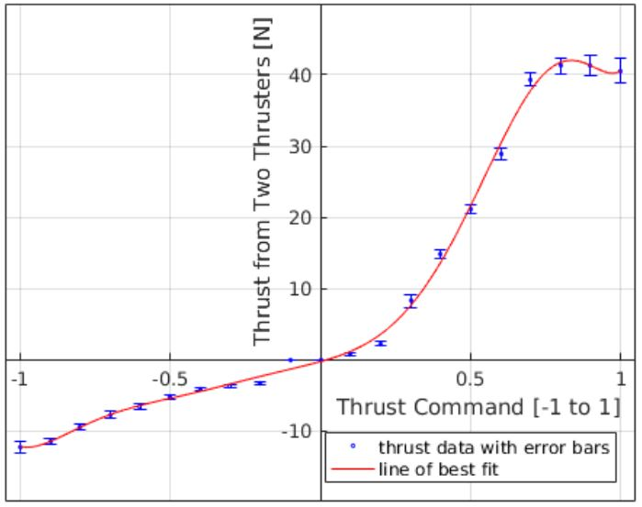

1. Thrust Command Relation. Source: [10]

## approach

The structure to the approach of testing was to conduct simulation-based testing to arrive at numerical solutions and then compare them to experimental real-life results with the USV. The simulation testing consisted of a process of incremental controller design and model dynamics. The controllers and techniques that resulted from simulation testing were incorporated into the experimental testing and then the overall trends and results were compared and analyzed.

### Test Cases for Comparison

The goal of this research is to test and evaluate the effectiveness of each of the control techniques individually and in varying combinations. The following defines the variables and their range of testing:

* **Speed Control:**
* Yes—High Speed (HS) or Low Speed (LS). Defined as  and step input respectively.
* No (NS). Defined as .
* **Heading Control:** Yes (HH) or No (NH). Yes defined as step input.
* **Feed-Forward:** Yes (FF) or No (NF).
* **Thrust Model:** Nonlinear (NL) or Linear (LL).

Each test case has one of the options noted previously and every combination was tested therefore we will define each test case by using the two letter tag for each variable in succession. For example, for a test case that was at low speed (LS), no heading (NH), with feed-forward (FF) and a nonlinear thrust model (NL); we would call this Test **LSNHFFNL**. Table 4 displays a simplified matrix identifying the varying test cases of consideration for this research

1. Test Case Definition Matrix

|  |  |  |  |
| --- | --- | --- | --- |
| **Speed and Heading Control** | **Feed-Forward**  **(FF/​NF)** | **Thrust Model**  **(LL/​NL)** | **Number of Cases (Tested/​Possible)** |
| **Decoupled:**  Low Speed  Constant Heading | Tested for both cases | Tested for both cases | 4/​4 |
| **Decoupled:**  High Speed  Constant Heading | Tested for both cases | Tested for both cases | 4/​4 |
| **Decoupled:**  No Speed  45 Deg Change | Not tested | Tested for both cases | 2/​4 |
| **Coupled:**  Low Speed  45 Deg Course | Not Tested | Not Tested | 0/​4 |
| **Coupled:**  High Speed  45 Deg Course | Feed-forward (FF) tested only | Tested for non-linear model only | 1/​4 |

### Tuning Methods Discussion

A fundamental basis of this research is the comparison of tuning requirements for different controller techniques. This comparison is part-objective and part-subjective for many professionals in the field of control. It is an inherent and most often user-dependent property of conducting any form of control. This means that a certain control technique could be proper choice of a system but can be unsuccessful due to being improperly tuned. A difficulty of this research and an aspect that will be discussed in the further recommendations is developing a robust method to determine the difficulty of tuning. Ultimately, and as will be discussed in the conclusions, the comparison between techniques is heavily favored towards subjectively but the following methods were this research’s progress towards defining objectivity as it relates to tuning.

#### Ziegler-Nichols Application

The first method that was attempted to standardized the tuning approach was the application of Ziegler-Nichols PID tuning rules as defined by their groundbreaking work in automation control [19]. They consist of analyzing the closed-loop system response with a PID controller and systematically tuning gains with respect to specific time constants and response parameters. A generalized set of steps as attempted for this research is as following [13], [19], [20]:

1. Set the effect of the integrator and derivative parts of the PID controller to zero.
2. Set the gain constant, *KP,* to zero and then slowly increase until there are sustained oscillations.
3. Record this value of *KP* as the critical gain, *Kcrit,* and identify and record the period associated with the oscillations as *Tcrit.*
4. Initially set the time constant,  , associated with the integrator and the time constant,,associated with the derivative according to the rules in Table 4.
5. Ziegler-Nichols Tuning Rules

|  |  |  |  |
| --- | --- | --- | --- |
| Control Type | KP |  |  |
| P |  | - | - |
| PI |  |  | - |
| PID |  |  |  |

Unfortunately, when implemented, the system never reached steady-state oscillations and was unable to utilize it.

#### Testing Against Common Gains

In lieu of utilizing a testing protocol like the aforementioned Ziegler-Nichols, all simulation test cases that are generalized in Table 4 were tested against a similar set of gain constants, ,, andas is consistent with a PID modeled off Equation (8). These gains were varied to test the sensitivity of each test case to the changes of effect to the proportional, integral and derivative individually and then combined PID controllers with varied proportions. This resulted in each simulation test case being tested at a minimum of 18 trials (see Table 6) and then each controller was individually tuned based on the 18 responses thus providing a basis of objective comparison for controller tuning. This amount of testing was not feasible and not implemented in the experimental testing but provides a basis for further research.

1. Gain Constant Testing Values

|  |  |  |  |
| --- | --- | --- | --- |
| **Test #** |  |  |  |
| **1** | 1 | 0 | 0 |
| **2** | 10 | 0 | 0 |
| **3** | 100 | 0 | 0 |
| **4** | 1 | 1 | 0 |
| **5** | 1 | 0.01 | 0 |
| **6** | 1 | 0.1 | 0 |
| **7** | 1 | 10 | 0 |
| **8** | 1 | 100 | 0 |
| **9** | 1 | 0 | 1 |
| **10** | 1 | 0 | 0.01 |
| **11** | 1 | 0 | 0.1 |
| **12** | 1 | 0 | 10 |
| **13** | 1 | 0 | 100 |

THIS PAGE INTENTIONALLY LEFT BLANK

# simulation results and analysis

## simulation setup

Both MATLAB and Simulink were the software chosen to conduct the numerical and simulation based testing. MATLAB was utilized for iteration scripting, result analyses, plotting and data export. Simulink was the model-based framework for building the control process and conducting the tests. Figures 8–11 represent portions and examples of actual Simulink block diagrams that were used for numerical testing.

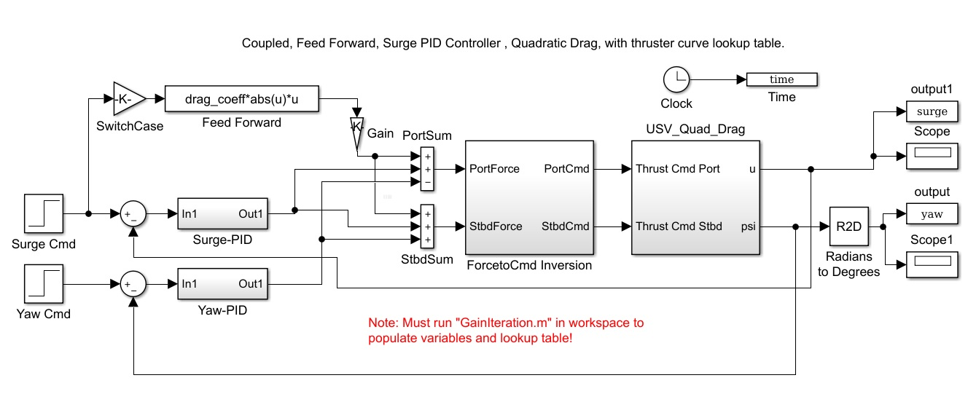

1. Complete Simulation Model—Top Layer

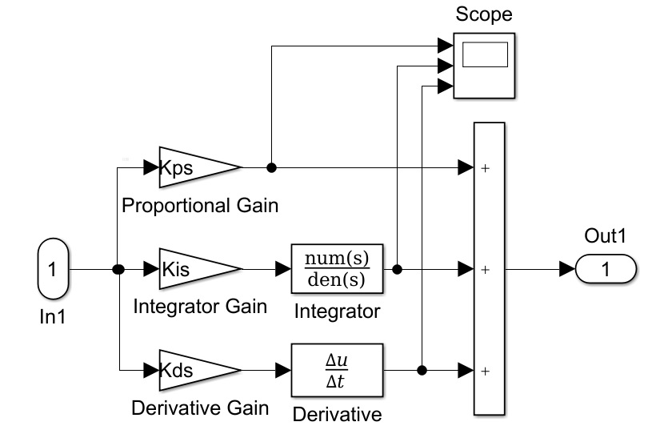

1. PID Controller—Sub-Layer

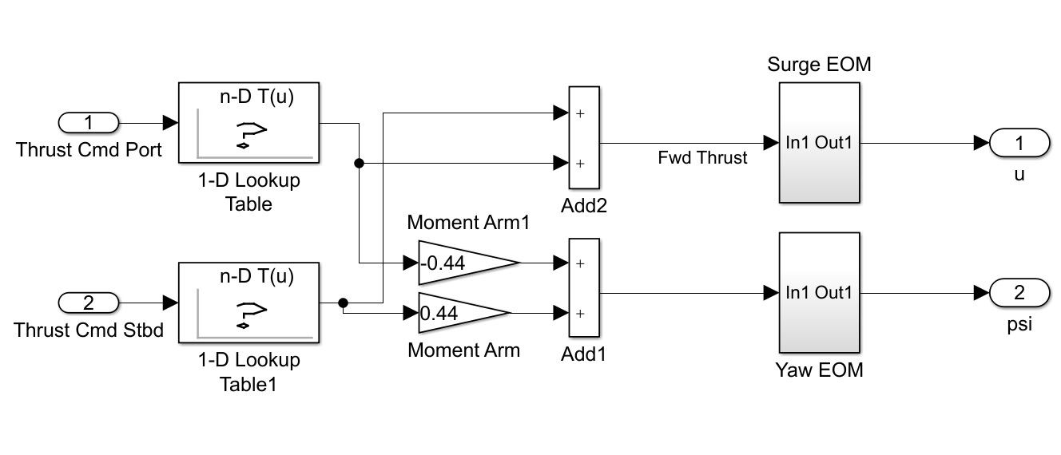

1. USV Simulation Model—Sub-Layer

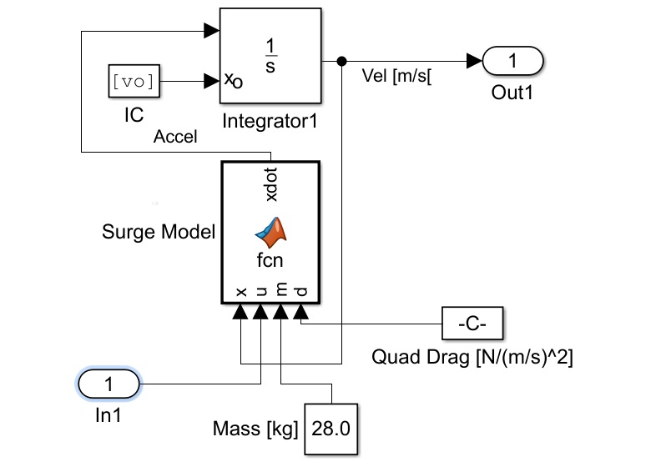

1. USV Equations of Motion—Sub-Layer

## MODEL VERIFICATION

A Simulink verification of the open-loop system (see Figure 13) was conducted to ensure validity of the USV model prior to conducting feedback control testing. Simulations were conducted over a range of motor commands, [0.0 to 1.0], which were converted to forces utilizing the same relationship displayed in Figure 7. Table 7 displays the numerical results of these tests. This data was then compared to the experimental results from Manzini who had correlated steady linear and angular velocity to thrust generation from the KF-USV in order to estimate the drag coefficient. Manzini conducted three variations of curve fitting, , for the linear and angular velocity data respectively. The quadratic only form, , formed the best fit for both cases and the coefficient, *a*, was the basis of the quadratic drag terms identified in Table 2. Figure 12 confirms and validates that the numerical model matches the assumptions stated in previous sections.

1. Model Verification Results

|  |  |  |  |  |  |  |  |  |  |  |
| --- | --- | --- | --- | --- | --- | --- | --- | --- | --- | --- |
| **Thrust Cmd** | 0.1 | 0.2 | 0.3 | 0.4 | 0.5 | 0.6 | 0.7 | 0.8 | 0.9 | 1.0 |
| **Force [N]** | 0.6 | 2.2 | 8.2 | 14.8 | 21.0 | 28.8 | 39.4 | 41.2 | 41.4 | 40.6 |
| **Linear Velocity [m/​s]** | 0.1884 | 0.3608 | 0.6966 | 0.9358 | 1.1187 | 1.3054 | 1.5268 | 1.5612 | 1.5647 | 1.5499 |
| **Torque [N*m]** | 0.1320 | 0.4840 | 1.8040 | 3.2560 | 4.6200 | 6.3360 | 8.6680 | 9.0640 | 9.1080 | 8.9320 |
| **Angular Velocity [rad/​s]** | 0.0308 | 0.059 | 0.1139 | 0.1529 | 0.1823 | 0.2134 | 0.2497 | 0.2553 | 0.2559 | 0.2535 |

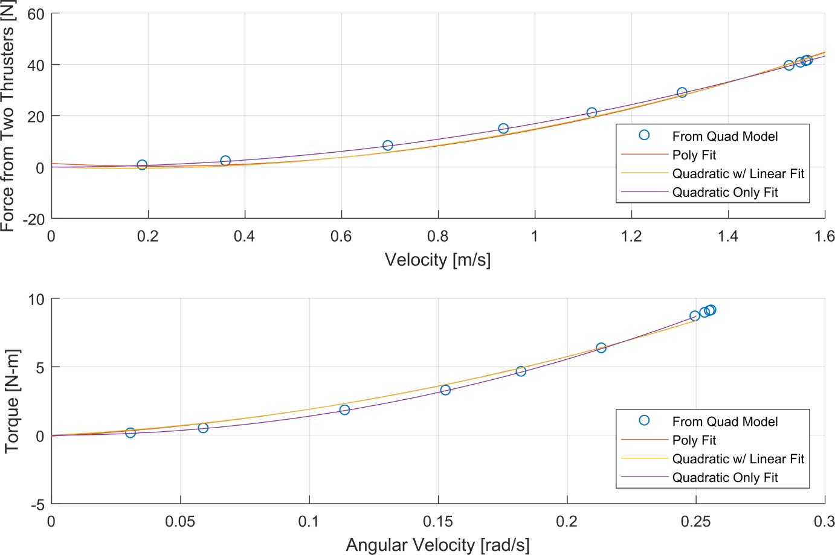

1. Model Verification Results

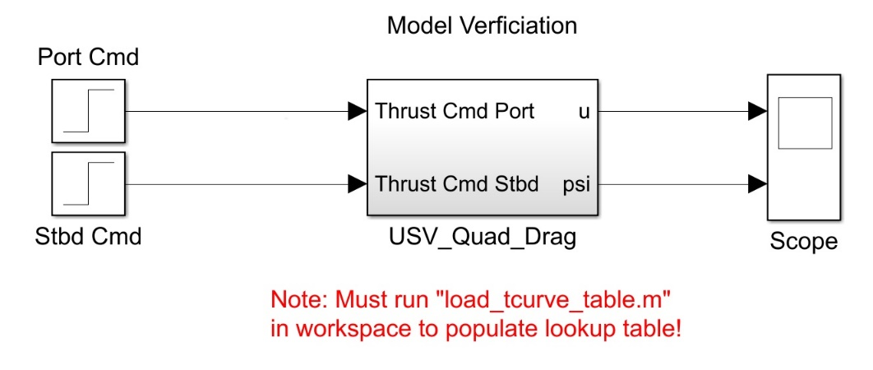

1. Open-Loop USV Model

## decoupled dynamics

The first set of testing conducted after the model verifications was on the decoupled system and analyzing the heading (yaw) and speed (surge) control independently.

### Heading Control

The basis of decoupled heading control was to analyze a 45-degree step input with simple feedback and a PID controller with zero feedback or control to speed. The approach for this testing was to test and tune the simple PID controller for the linear thrust relationship and then for the non-linear thrust relationship. First, heading control was systematically tested and analyzed for trends utilizing the tuning approach as presented in Table 6. Figures 14 and 15 displays the varying effect of the heading control with a linear thrust and non-linear thrust model approximation respectively. The plots are organized from top-to-bottom by effects of the varying the proportional-only, integral-only, and derivative-only gains.

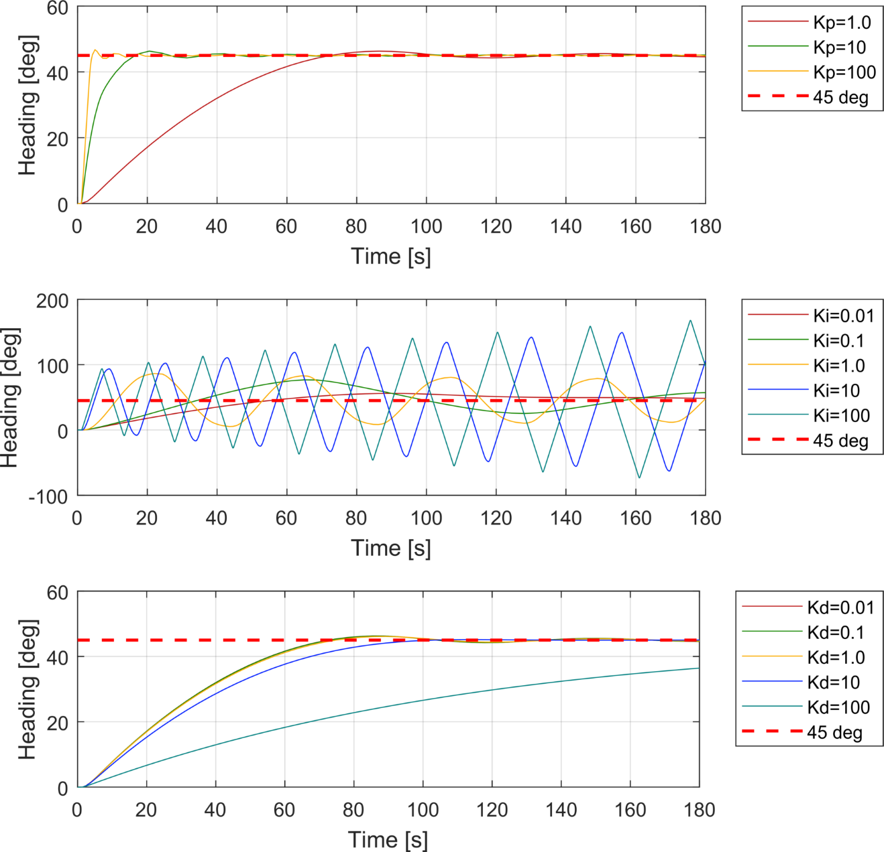

1. Tuning Step Responses—Heading Control—Linear Thrust Model Approximation

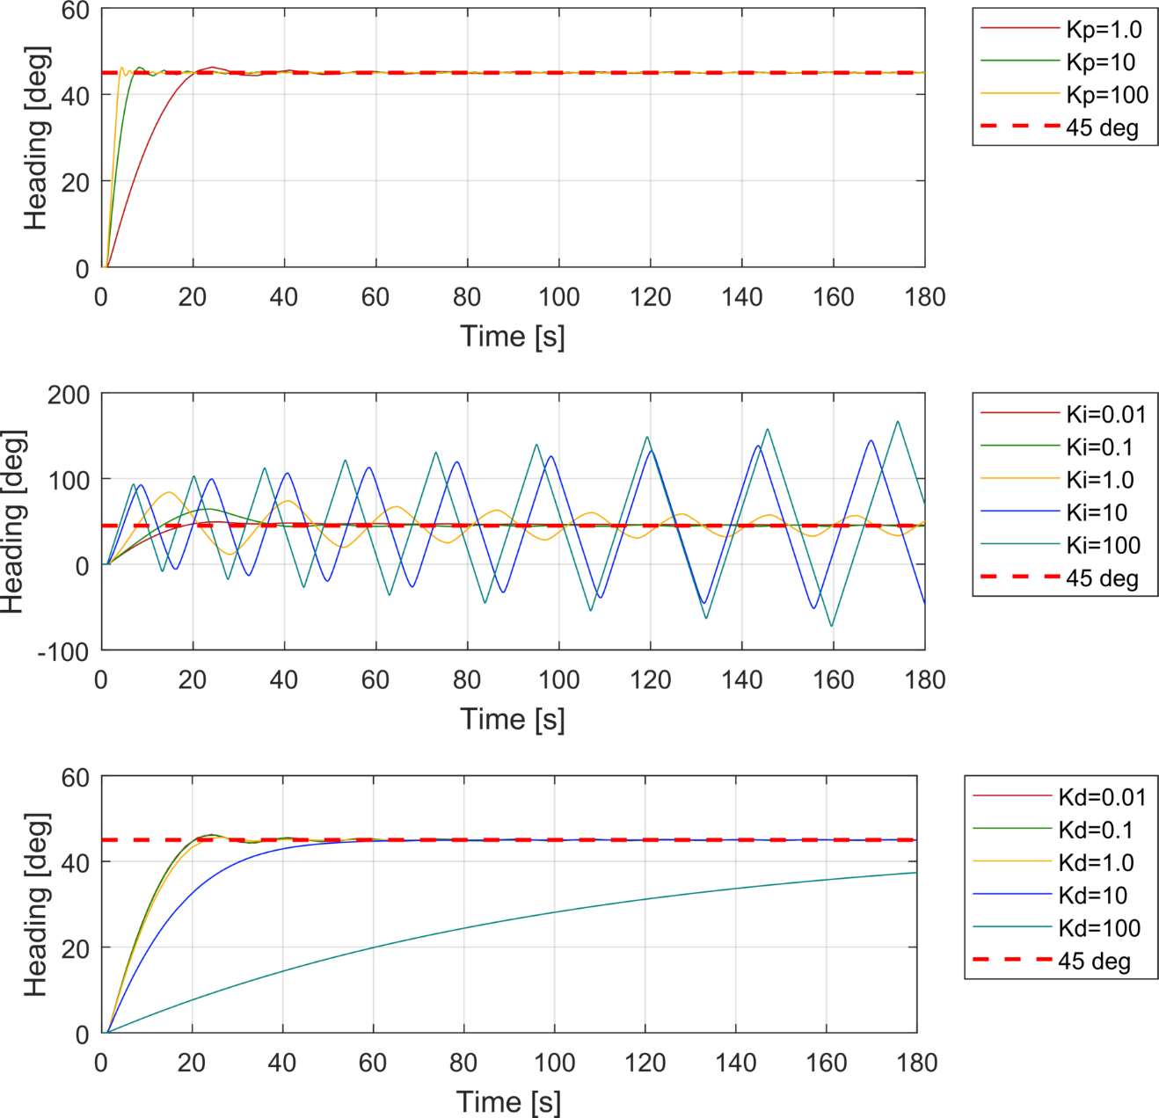

1. Tuning Step Responses—Heading Control—Non-Linear Thrust Model Approximation

From the plots, we can identify the following common trends:

1. Increasing the proportional gain improves response time but increases overshoot.
2. Increasing the integral gain drives the system unstable and should be set near zero.
3. Increasing the derivative gain slows systems response and decreases overshoot.
4. The system responds best to a PID controller most closely resembling a Proportional-Derivative (PD) controller.

Table 8 compares the performance characteristics of linear (L) and non-linear (NL) step responses from the proportional (top plot) and derivative (bottom plot) in Figures 14 and 15. As this data indicates, even before fine-tuning the controllers, the non-linear thrust model presents advantages over the linear approximation in terms of rise time, *TR*, settling time, *TS* and percent overshoot, *OS.*

1. Heading Control—Linear and Non Linear Thrust Model Approximation—Step Response Characteristic Comparison

|  |  |  |  |  |  |  |  |  |  |  |
| --- | --- | --- | --- | --- | --- | --- | --- | --- | --- | --- |
| **Gains** | | ***Rise Time, TR* [s]** | | | ***Settling Time, TS*[s]** | | | ***Overshoot, OS* [%]** | | |
| **Kp** | **Kd** | **L** | **NL** | **Δ [s]** | **L** | **NL** | **Δ [s]** | **L** | **NL** | **Δ [%]** |
| 1 | 0 | 51.0 | 13.40 | **37.60** | 70.00 | 26.80 | **43.20** | 2.00 | 3.20 | **1.20** |
| 10 | 0 | 9.9 | 4.30 | **5.60** | 31.90 | 9.00 | **22.90** | 2.40 | 3.00 | **0.60** |
| 100 | 0 | 2.2 | 2.20 | **0.00** | 7.70 | 4.60 | **3.10** | 3.90 | 2.90 | **1.00** |
| 1 | 0.01 | 51.0 | 13.40 | **37.60** | 70.10 | 26.70 | **43.40** | 2.00 | 3.10 | **1.10** |
| 1 | 0.1 | 51.1 | 13.50 | **37.60** | 70.30 | 26.60 | **43.70** | 1.90 | 3.00 | **1.10** |
| 1 | 10 | 61.6 | 28.70 | **32.90** | 88.20 | 48.40 | **39.80** | 0.00 | 0.00 | **0.00** |
| 1 | 100 | 76.9 | 76.90 | **0.00** | 97.00 | 96.70 | **0.30** | 0.00 | 0.00 | **0.00** |

Although, once the controllers were optimally tuned to the same set of gains, they display near identical performance (see Figure 16) as numerical results show in Table 9. The responses are near overlapped with the non-linear curve exhibiting slightly less overshoot.

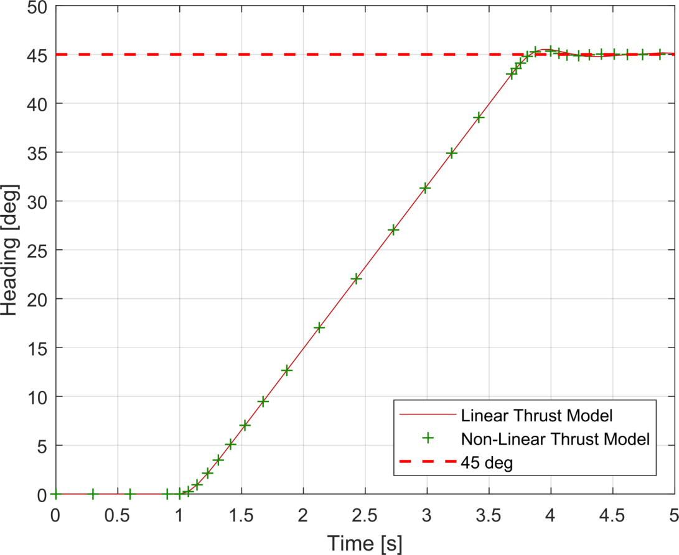

1. Heading Control—Optimized Step Response—Linear and Non-Linear Thrust Model Approximations
2. Heading Control—Optimized Controller—Step Response Characteristic Comparison

|  |  |  |  |  |  |  |  |  |  |  |  |
| --- | --- | --- | --- | --- | --- | --- | --- | --- | --- | --- | --- |
| **Gains** | | | ***Rise Time, TR* [s]** | | | ***Settling Time, TS*[s]** | | | ***Overshoot, OS* [%]** | | |
| **Kp** | **Ki** | **Kd** | **L** | **NL** | **Δ [s]** | **L** | **NL** | **Δ [s]** | **L** | **NL** | **Δ [%]** |
| 1000 | 0 | 50 | 2.16 | 2.16 | **0.00** | 3.75 | 3.75 | **0.00** | 1.2 | 0.8 | **0.4** |

### Speed Control

The basis of decoupled speed control was to analyze a the closed-loop response to a low-speed (0.0 to 0.25 [m/​s]) and high speed (1.25 to 1.50 [m/​s]) step response independently. The approach would be to test each of these speed regions with and without a feed-forward component and with either a linear or non-linear thrust model approximation. The goal of this simulation will be determine the effectiveness of like controller arrangements over the full spectrum (from low to high speed) and their effects on each speed region.

#### Low Speed Testing

##### Linear versus Non-Linear Thrust Model Comparison

First, the low-speed speed region was tested according to the gain schedule of Table 6 for the comparison of linear and non-linear thrust model approximation for identification of trends. Figures 17–18 display these results and are organized from top-to-bottom by effects of the varying the proportional-only, integral-only, and derivative-only gains respectively. From these figures we can evaluate the following trends common to both systems:

1. Increasing the proportional gain improves the system response.
2. A positive non-zero integration gain is necessary to reduce steady state error but can increase overshoot and oscillations.
3. A small derivative gain (*Kd* << 1) has negligible effect on system response but a gain larger a factor of 10 of greater increased system response but also increased steady state error.
4. The system responds best to a PID controller most closely resembling a Proportional-Integral (PI) controller.

Table 10 compares the performance characteristics of linear (L) and non-linear (NL) step responses from the proportional (top plot) and integral (middle plot) in Figures 17 and 18.

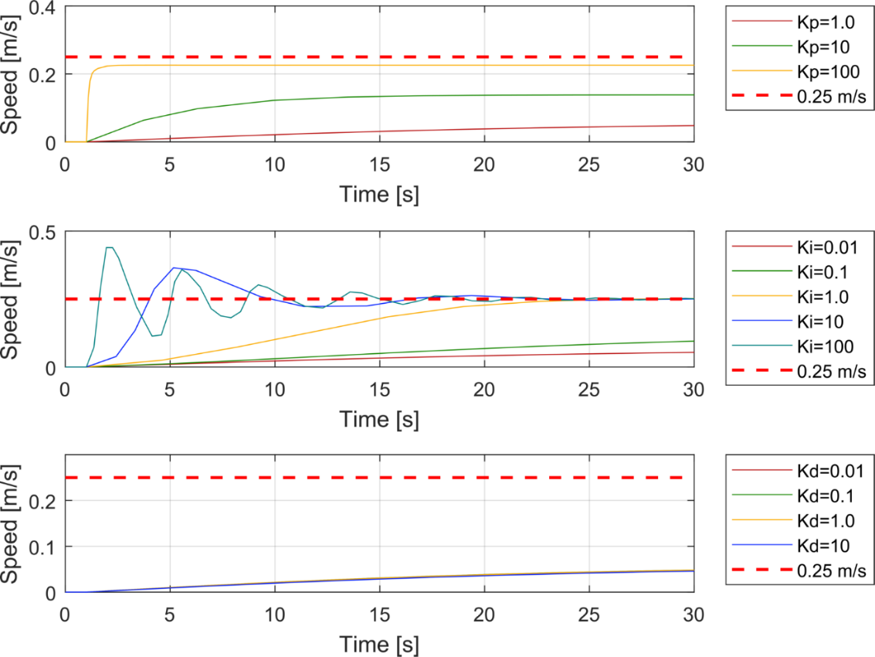

1. Tuning Step Responses—Low-Speed—Linear Thrust Model Approximation

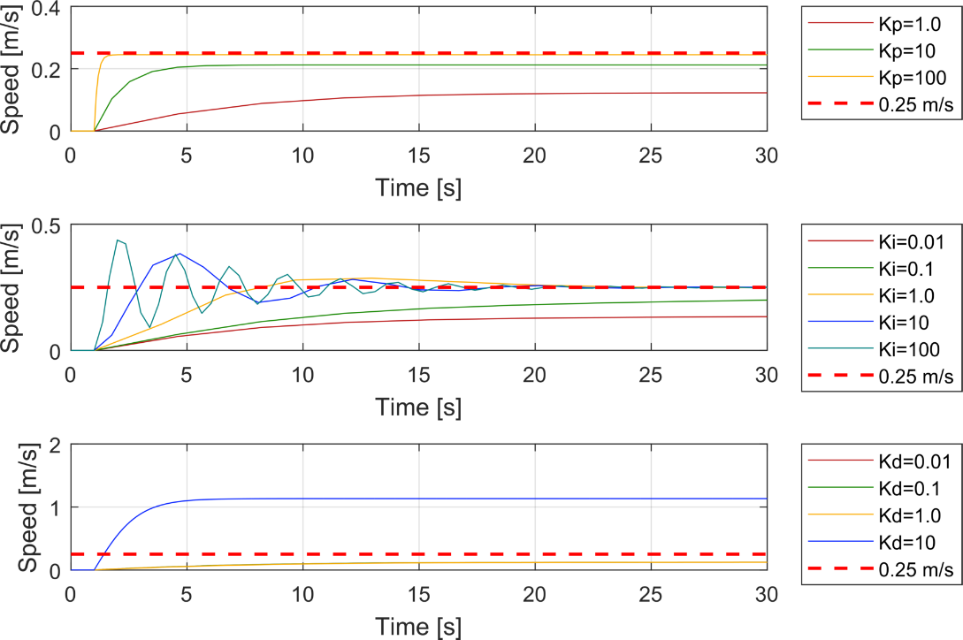

1. Tuning Step-Responses—Low Speed Control—Non-Linear Thrust Model Approximation
2. Performance Characteristic Comparison—Low-Speed Control—Linear and Non Linear Thrust Model Approximation

|  |  |  |  |  |  |  |  |  |  |  |
| --- | --- | --- | --- | --- | --- | --- | --- | --- | --- | --- |
| **Gains** | | ***Rise Time, TR* [s]** | | | ***Settling Time, TS*[s]** | | | ***Steady State Error* [m/​s]** | | |
| **Kp** | **Ki** | **L** | **NL** | **Δ [s]** | **L** | **NL** | **Δ [s]** | **L** | **NL** | **Δ [m/​s]** |
| 1 | 0 | 33.2 | 11.49 | **21.69** | 56.73 | 20.71 | **36.02** | 0.19 | 0 | **0.07** |
| 10 | 0 | 9.1 | 2.36 | **6.71** | 16.67 | 5 | **11.30** | 0.11 | 0 | **0.07** |
| 100 | 0 | 0.3 | 0.30 | **0.02** | 1.87 | 2 | **0.32** | 0.02 | 0 | **0.02** |
| 1 | 0.01 | 58.5 | 45.26 | **13.21** | 91.62 | 88 | **3.19** | 0.17 | 0 | **0.08** |
| 1 | 0.1 | 66.7 | 43.36 | **23.32** | 93.92 | 82 | **11.68** | 0.09 | 0 | **0.08** |
| 1 | 1 | 14.9 | 5.09 | **9.80** | 23.96 | 22 | **2.21** | 0.00 | 0 | **0.00** |
| 1 | 10 | 1.7 | 1.47 | **0.23** | 21.52 | 21 | **0.70** | 0.00 | 0 | **0.00** |
| 1 | 100 | 0.4 | 0.41 | **0.06** | 23.93 | 22 | **1.97** | 0.00 | 0 | **0.00** |

Similar to the heading control, the non-linear thrust model approximation provides improved system performance from the linear thrust model in rise time, settling time, and steady state error at the same test points. When the proportional and integral gains are increased a factor of 100 independently, the systems’ rise times and steady-state errors converge but the non-linear thrust model demonstrates improved performance in settling time. Also, similar to the heading control, is the observation that the system’s performance converges as their controllers are optimized through tuning. Figure 19 shows optimized responses and Table 11 shows the performance characteristics of each response.

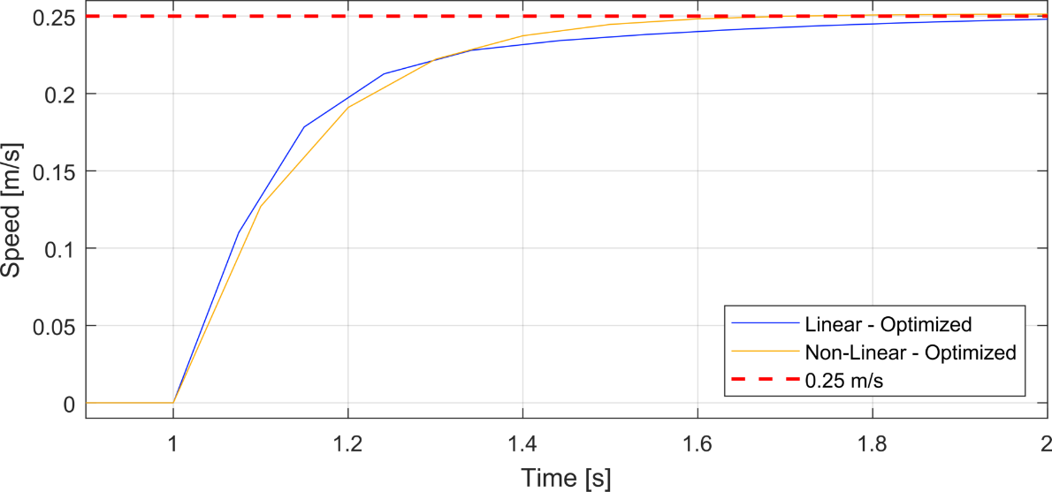

1. Optimized Step Responses—Low-Speed Control—Linear and Non-Linear Thrust Model Approximations
2. Optimized Performance Characteristics Comparison—Low-Speed Control—Linear and Non-Linear Thrust Model Approximations

|  |  |  |  |  |  |  |  |  |  |  |  |
| --- | --- | --- | --- | --- | --- | --- | --- | --- | --- | --- | --- |
| **Gains** | | | ***Rise Time, TR* [s]** | | | ***Settling Time, TS*[s]** | | | ***Steady State Error [m/​s]*** | | |
| **Kp** | **Ki**  (L/​NL) | **Kd** | **L** | **NL** | **Δ[s]** | **L** | **NL** | **Δ[s]** | **L** | **NL** | **Δ[m/​s]** |
| 100 | 80/​20 | 0.01 | 0.65 | 0.30 | **0.35** | 1.97 | 1.53 | **0.44** | 0.00 | 0.00 | **0.00** |

##### Feed-Forward Compensation Testing

Following testing of the thrust model approximation, the system was tested with and without the use of a feed-forward term. As previously discussed and graphically displayed in Figure 6, our definition of feed-forward compensation is analogous to command-compensated control. This implies that assuming we know a relationship of the model to a range of set-points, we can predict certain dynamics of the response and use that advantageously. In this research, we assume that we understand the relationship from commanded velocity and the thrust required based on Equation (4). If assume steady-state velocity (i.e.  ), then the thrust required,  , is a relationship of the drag components and commanded velocity as generalized in Equation (9).



Then by incorporating the appropriate values from Table 2 for the drag coefficients, our relationship is reduced to Equation (10) as the total thrust needed for two thrusters. Figure 20 provides one example and iteration of a Simulink model used incorporating feed-forward for these simulations.



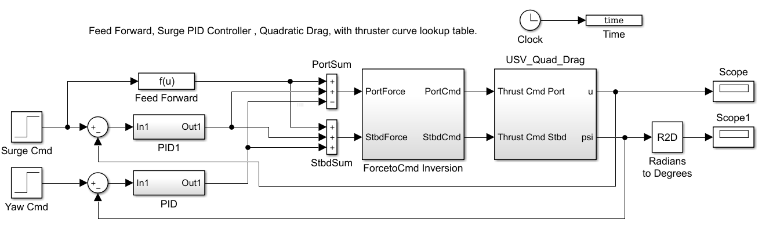

1. Speed Control with Feed-Forward Architecture in Simulink Model

For this testing, we configured for a linear thrust model approximation and conducted the same systematic tuning steps as the previous sections (see Table 6 for gain schedule) to service as a basis for comparison. In addition to observing the step-response and accompanying characteristics, the integrator’s effort was also recorded for analyzing effect of integrator wind-up. Figures 21–22 display these results and are organized from top-to-bottom by effects of the varying the proportional-only, integral-only, and derivative-only gains respectively. From these figures, we observe that both systems demonstrate the same trends as the speed-control stated in the previous section and will respond to a PI controller. This is expected as the model of the plant is identical and the feed-forward does not change the inherent dynamics of the plant. Table 12 compares the performance characteristics of the non-feed-forward (NF) and the feed-forward (FF) step responses from the proportional and integral plots in Figures 21–22.

1. Performance Characteristics Comparison—Low-Speed Control—Feed Forward Compensation

|  |  |  |  |  |  |  |  |  |  |  |
| --- | --- | --- | --- | --- | --- | --- | --- | --- | --- | --- |
| **Gains** | | ***Rise Time, TR* [s]** | | | ***Settling Time, TS*[s]** | | | ***Steady State Error* [m/​s]** | | |
| **Kp** | **Ki** | **NF** | **FF** | **Δ [s]** | **NF** | **FF** | **Δ [s]** | **NF** | **FF** | **Δ [m/​s]** |
| 1 | 0 | 33.18 | 19.26 | **13.91** | 56.73 | 33.38 | **23.35** | 0.19 | 0.14 | **0.05** |
| 10 | 0 | 9.07 | 7.81 | **1.27** | 16.67 | 14.82 | **1.85** | 0.11 | 0.09 | **0.02** |
| 100 | 0 | 0.28 | 0.28 | **0.00** | 1.87 | 1.89 | **0.02** | 0.02 | 0.02 | **0.00** |
| 1 | 0.01 | 58.47 | 25.08 | **33.39** | 91.62 | 74.96 | **16.66** | 0.17 | 0.13 | **0.04** |
| 1 | 0.1 | 66.68 | 59.04 | **7.64** | 93.92 | 91.45 | **2.48** | 0.09 | 0.08 | **0.01** |
| 1 | 1 | 14.89 | 13.36 | **1.54** | 23.96 | 20.54 | **3.43** | 0.00 | 0.00 | **0.00** |
| 1 | 10 | 1.70 | 1.94 | **0.24** | 21.52 | 21.25 | **0.27** | 0.00 | 0.00 | **0.00** |
| 1 | 100 | 0.35 | 0.34 | **0.00** | 23.93 | 24.08 | **0.15** | 0.00 | 0.00 | **0.00** |

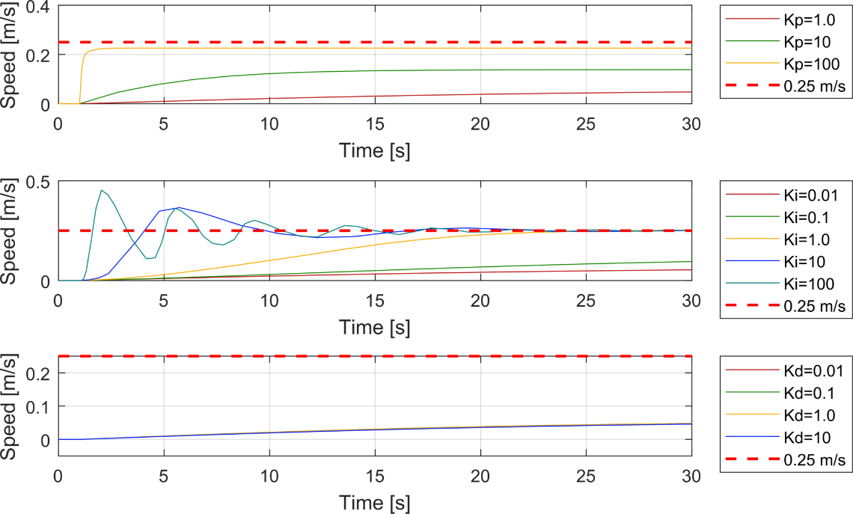

1. Tuning Step Responses—Low-Speed Control without Feed-Forward Compensation

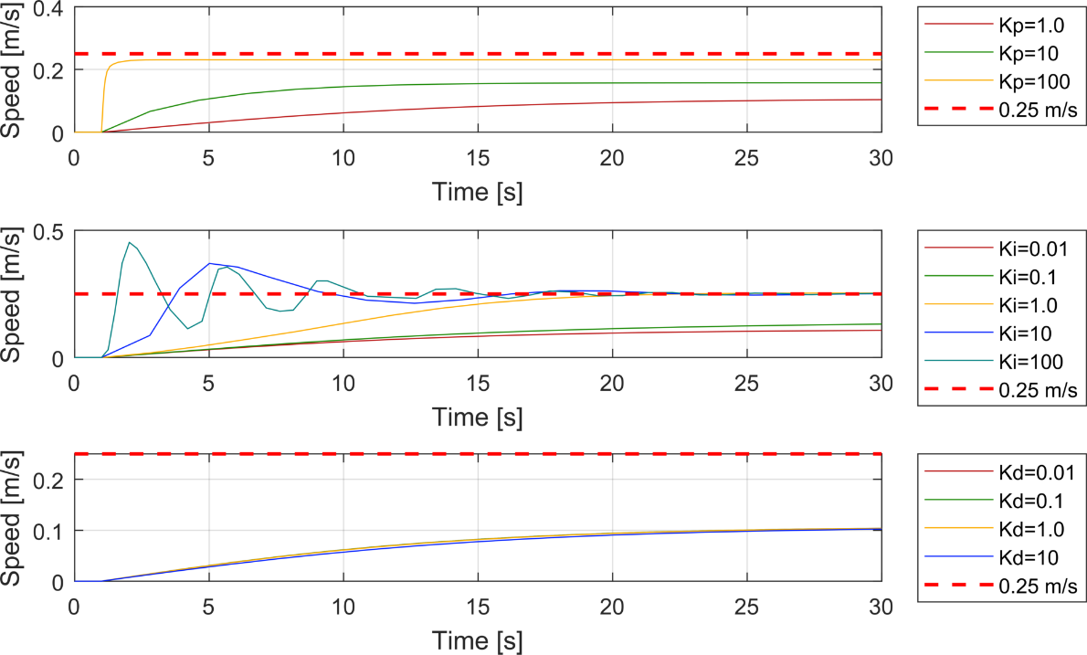

1. Tuning Step Responses—Low-Speed Control with Feed-Forward Compensation

The feed-forward compensation does provide benefit without increased tuning in system response but is less than the benefit that the dynamic thruster model provides with the same comparison of tuning. As the systems are tuned with greater effect, the benefits begin to dissipate and produce near same performance characteristics. Again, similar to the previous tests, once both systems are tuned with similar effort, their responses are almost identical as is represented graphically in Figure 23 and numerically in Table 13.

1. Optimized Performance Characteristics—Low-Speed Control—Feed-Forward Compensation

|  |  |  |  |  |  |  |  |  |  |  |  |
| --- | --- | --- | --- | --- | --- | --- | --- | --- | --- | --- | --- |
| **Gains** | | | ***Rise Time, TR* [s]** | | | ***Settling Time, TS*[s]** | | | ***Steady State Error [m/​s]*** | | |
| **Kp** | **Ki**  (NF/​FF) | **Kd** | **NF** | **FF** | **Δ[s]** | **NF** | **FF** | **Δ[s]** | **NF** | **FF** | **Δ[m/​s]** |
| 100 | 80/​50 | 0.01 | 0.65 | 0.32 | **0.33** | 1.97 | 2.04 | **0.06** | 0.00 | 0.00 | **0.00** |

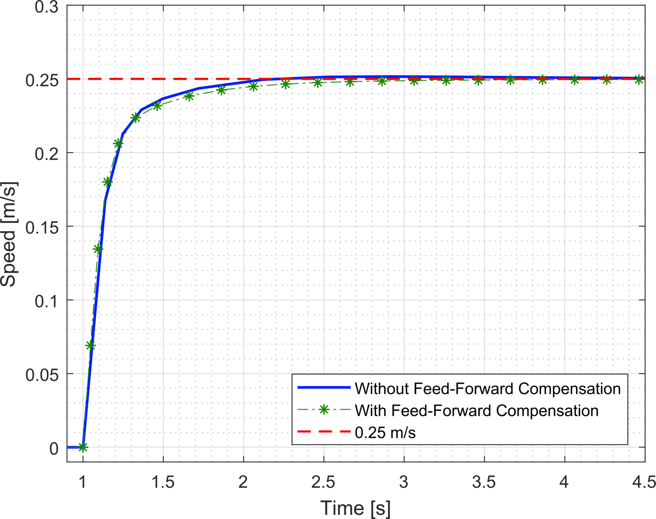

1. Optimized Step Response—Low-Speed Control—Feed Forward Control

The feed-forward compensation does provide decreased integrator effort and prevents integrator wind-up as it displayed in Figure 24. Specifically, the system without feed-forward compensation, has integrator overshoot before arriving at a steady state and is indicative of wind up or over-accumulation of error that the system then has to resolve. The smaller steady state associated with the feed-forward compensation is due to the feed-forward term consistently off-setting the error of the system and diminishing the effect of the integrator.

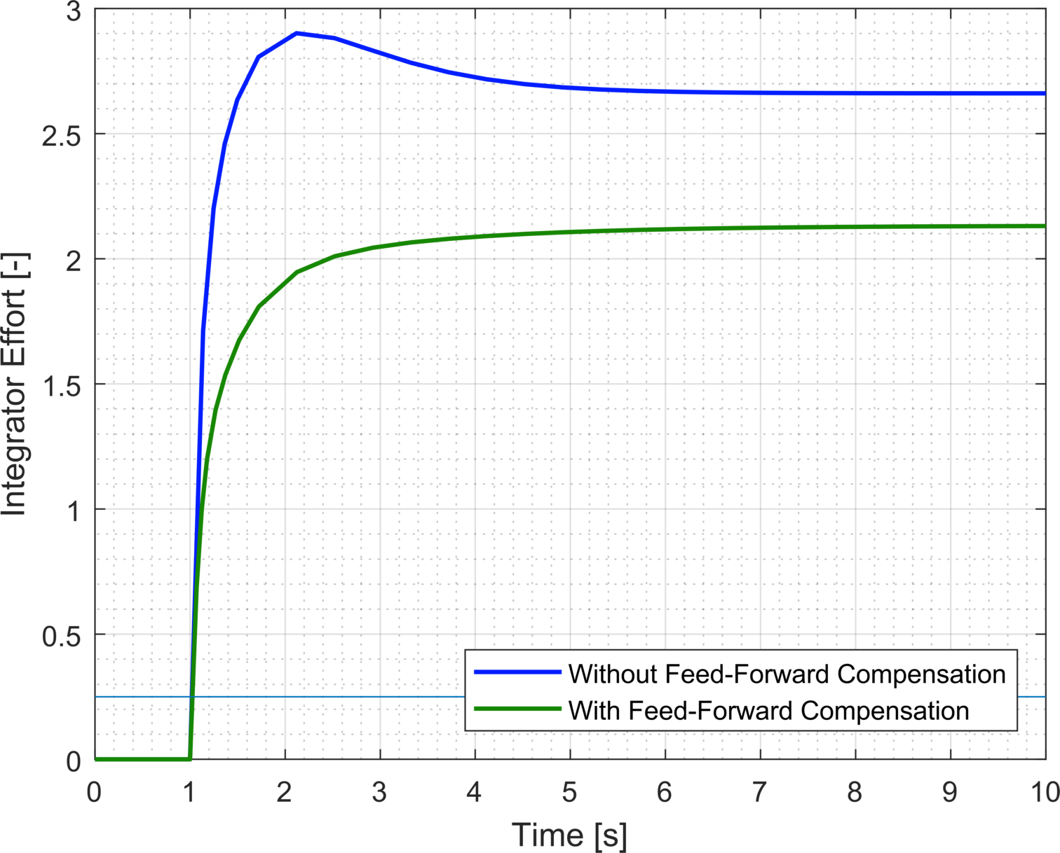

1. Optimized System Response—Feed-Forward Compensation—Integrator Effort Comparison

#### High-Speed Controller Testing

##### Linear versus Non-Linear Thrust Model Comparison

First, the high-speed region, 1.25—1.50 [m/​s], was tested according to the gain schedule of Table 6 for the comparison of linear and non-linear thrust model approximation for identification of trends. The step change was initiated at a time of 60 seconds to allow for the system to stabilize at the lower set point. Figures 25–26 display these results and are organized from top-to-bottom by effects of the varying the proportional-only, integral-only, and derivative-only gains respectively. From these figures, it is clear that most of the controllers are inadequate and fail to even obtain a steady-state at the lower set-point. The differences in the linear and non-linear thrust models are subtle and do not provide any substantial comparison. Due to the previously ascertained knowledge of this system requiring a PI modeled controller, we initiated another series of tuning identified in Table 14.

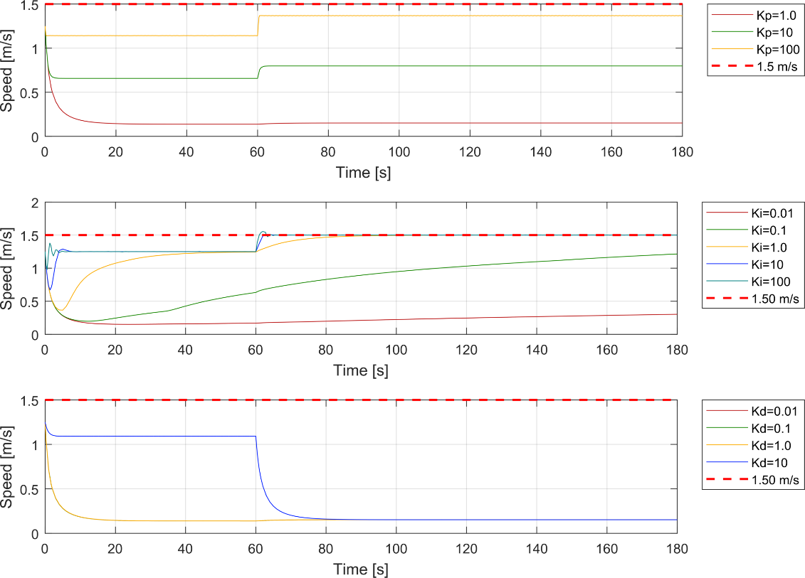

1. Tuning Step Responses—High-Speed—Linear Thrust Model Approximation

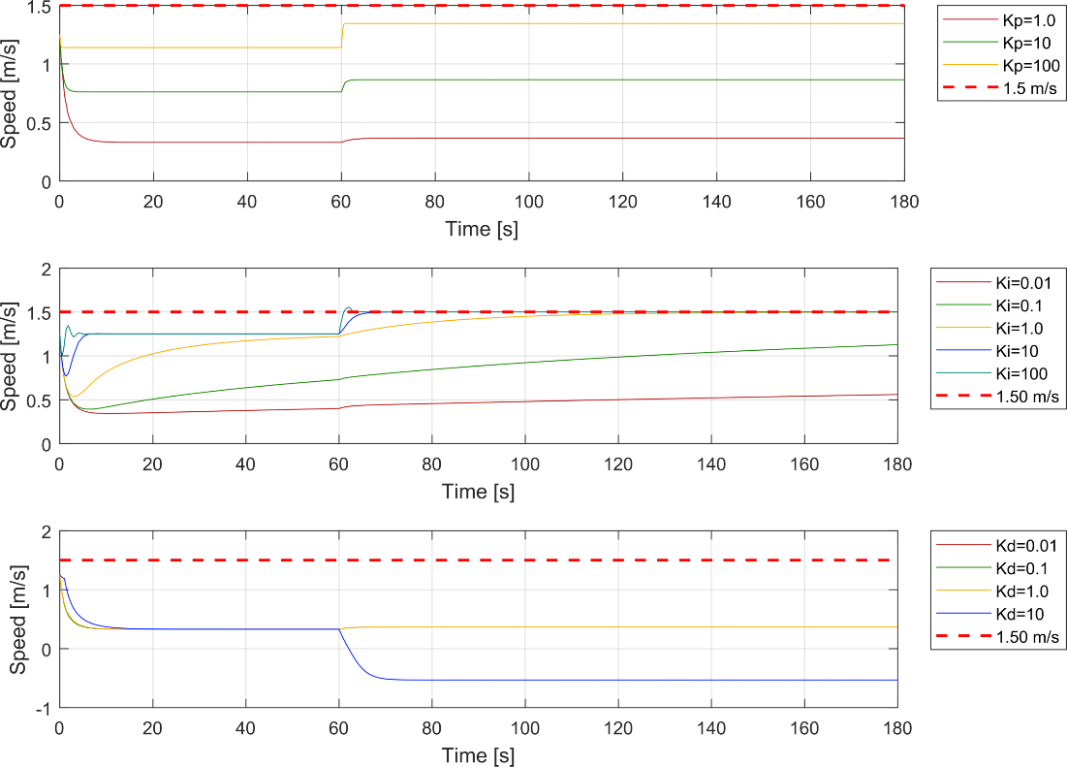

1. Tuning Step-Responses—High Speed Control—Non-Linear Thrust Model Approximation
2. High Speed Control—Refined Tuning Gain Table

|  |  |  |  |
| --- | --- | --- | --- |
| **Test #** |  |  |  |
| **14** | 100 | 100 | 0 |
| **15** | 100 | 250 | 0 |
| **16** | 100 | 500 | 0 |
| **17** | 100 | 750 | 0 |
| **18** | 100 | 1000 | 0 |

Using this testing schedule, the systems were re-tested and their results are plotted in Figure 27 where the linear thrust approximation is located in the top plot and the non-linear thrust approximation in the lower. From these figures, it is visually deducible that the non-linear thrust model approximation offers some advantages in systems response but they are not near the discernable differences that were available in the low-speed region.

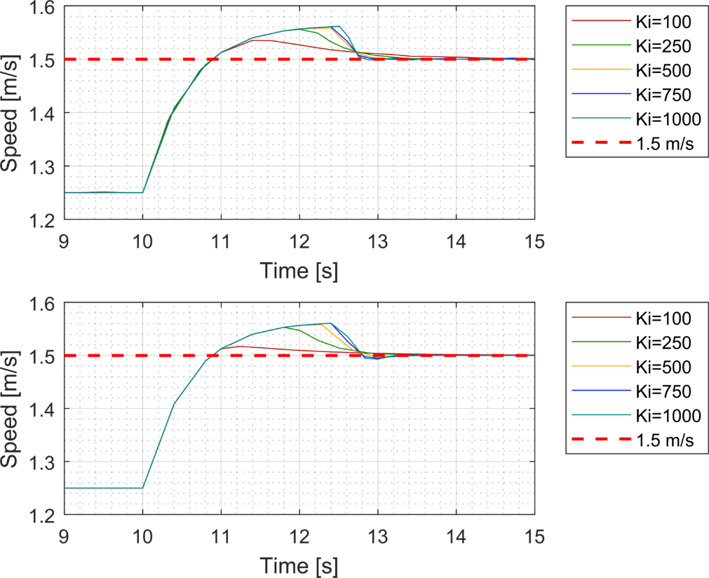

1. Tuning Step-Response—High-Speed Control—Second Gain Testing Iteration

Figure 28 and Table 15 provide the graphical and numerical representations of the optimized responses for both systems. Expectedly, they are near identical responses but this information will be helpful in later sections when understanding advantages for controllers across a larger velocity spectrum.

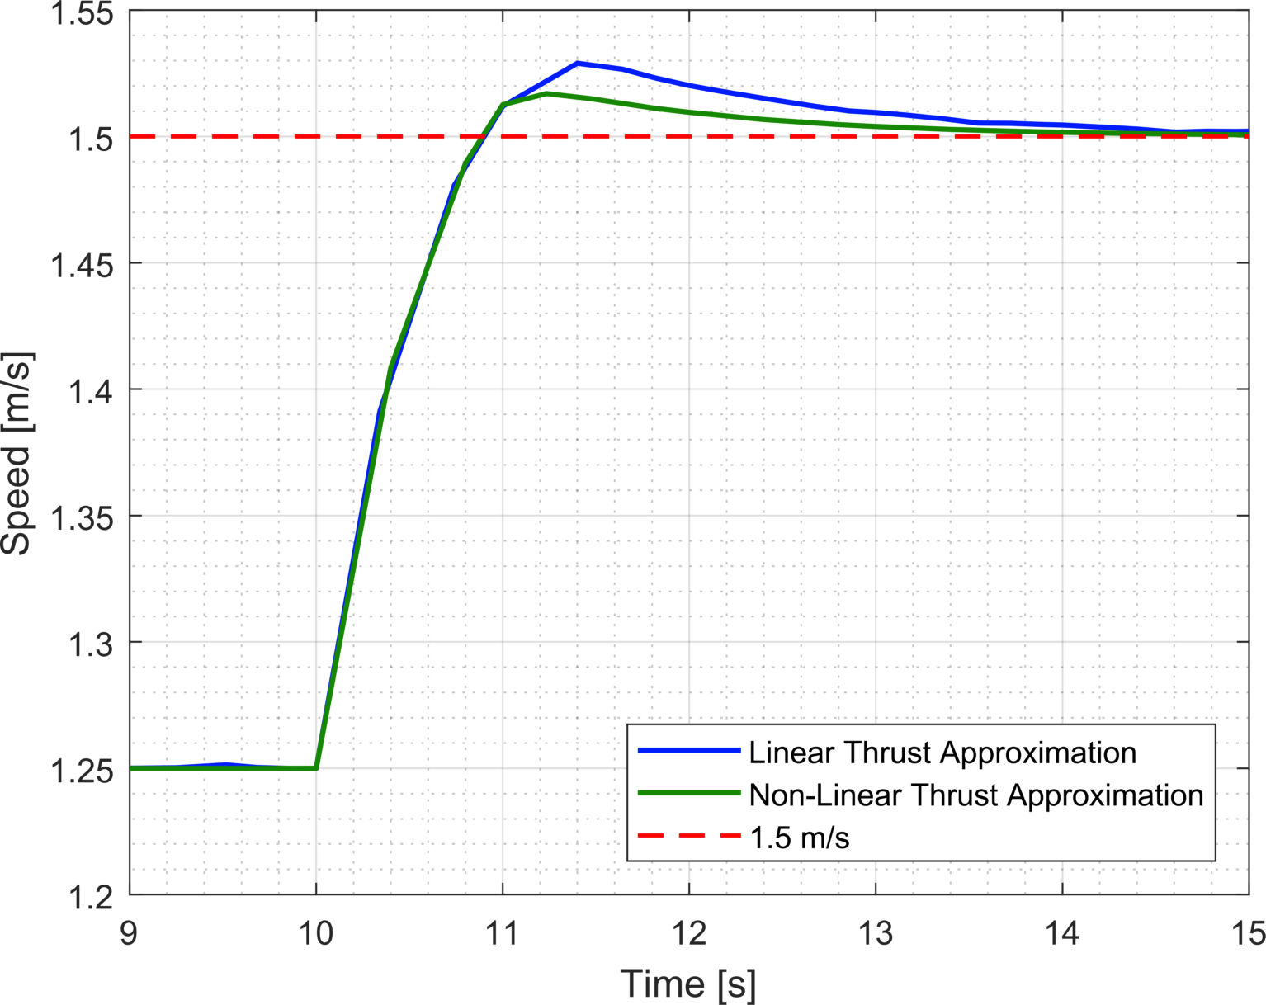

1. Optimized Step-Response—High-Speed—Linear and Non-Linear Thrust Model Approximations
2. Optimized Performance Characteristics—High Speed—Linear and Non-Linear Thrust Model Approximations

|  |  |  |  |  |  |  |  |  |  |  |  |
| --- | --- | --- | --- | --- | --- | --- | --- | --- | --- | --- | --- |
| **Gains** | | | ***Rise Time, TR* [s]** | | | ***Settling Time, TS*[s]** | | | ***Overshoot [%]*** | | |
| **Kp** | **Ki**  (L/​NL) | **Kd** | **L** | **NL** | **Δ[s]** | **L** | **NL** | **Δ[s]** | **L** | **NL** | **Δ[%]** |
| 100 | 80/​100 | 0.01 | 0.65 | 0.65 | 0.00 | 1.97 | 1.96 | 0.01 | 0.28 | 0.10 | 0.18 |

##### Feed-Forward Compensation Testing

For the high-speed testing, the same architecture and relationships are assumed for a feed forward compensator as in the low-speed region. Also, the same systematic tuning steps as the previous sections (see Table 6 for gain schedule) are conducted to serve as a basis for comparison. In addition to observing the step-response and accompanying characteristics, the integrator’s effort was also recorded for analyzing effect of integrator wind-up. Figures 29–30 display these results and are organized from top-to-bottom by effects of the varying the proportional-only, integral-only, and derivative-only gains respectively. From these figures, we can observe that the feed-forward compensation has significant benefit to the system. Comparing just the plots of the proportional gain iterations of both systems show that the base feedback system response (i.e., *KP* = 1) of the system with feed-forward compensation quickly reaches steady states near both set points, 1.25 and 1.50 [m/​s], with steady state error. Whereas, the system without feed-forward compensation has a maximum velocity attainable is unable to respond to changes in set-point. This advantage is consistent across the various tuning gains and controller effects.

For the optimized system responses, displayed in Figure 31, the feed-forward compensated system has a near identical rise time as the uncompensated system but displays more overshoot and a slower settling time (see Table 16). These systems received similar tuning iterations to compare results but even with more tuning to the compensated system did not provide better response than the uncompensated.

Additionally, the compensated system does provide decreased integrator effort and prevents integrator wind-up as it displayed in Figure 31. The integrator for the uncompensated system is consistently accumulating error in order to maintain a high speed steady state whereas the compensated system’s integrator effort is minimized. Another facet present in this figure is the indication that the integrator is actually working to remove effort from the controller overall by providing a negative effort in order to maintain a steady state.

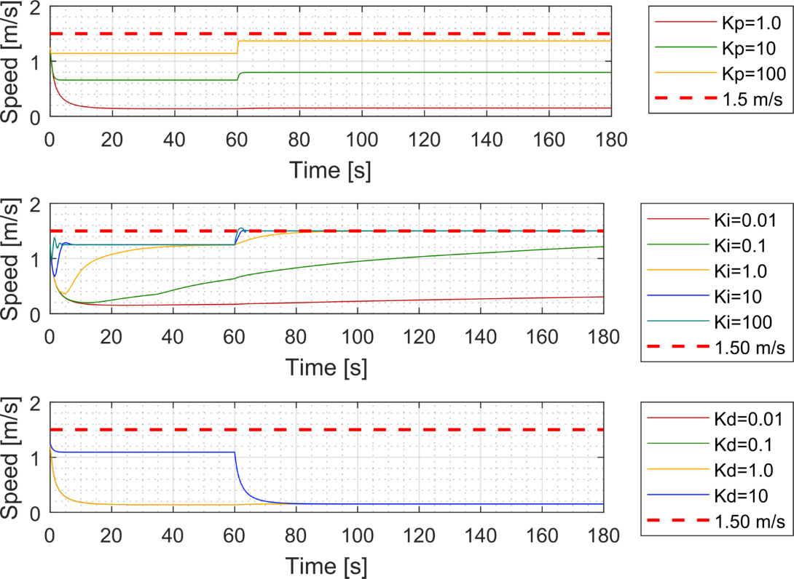

1. Tuning Step Responses—High-Speed Control without Feed-Forward Compensation

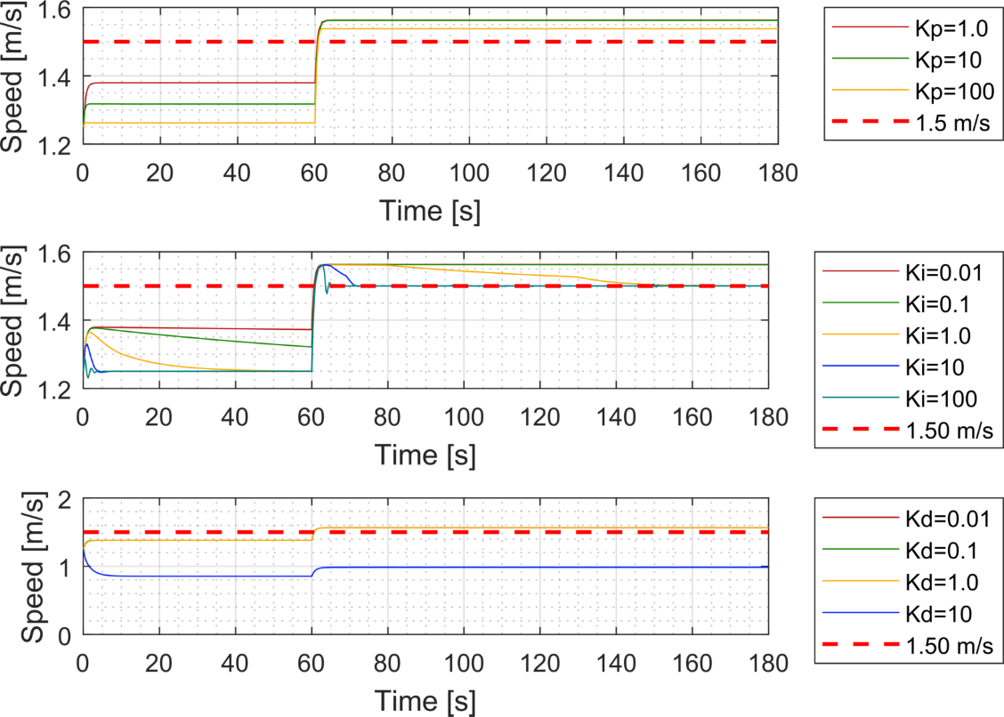

1. Tuning Step Responses—High-Speed Control with Feed-Forward Compensation
2. Optimized Performance Characteristics—Low-Speed Control—Feed-Forward Compensation

|  |  |  |  |  |  |  |  |  |  |  |  |
| --- | --- | --- | --- | --- | --- | --- | --- | --- | --- | --- | --- |
| **Gains** | | | ***Rise Time, TR* [s]** | | | ***Settling Time, TS*[s]** | | | ***Overshoot [%]*** | | |
| **Kp** | **Ki**  (NF/​FF) | **Kd** | **NF** | **FF** | **Δ[s]** | **NF** | **FF** | **Δ[s]** | **NF** | **FF** | **Δ[%]** |
| 100 | 80/​100 | 0.01 | 0.65 | 0.68 | **0.03** | 1.97 | 5.91 | **3.93** | 0.28 | 3.67 | **3.38** |

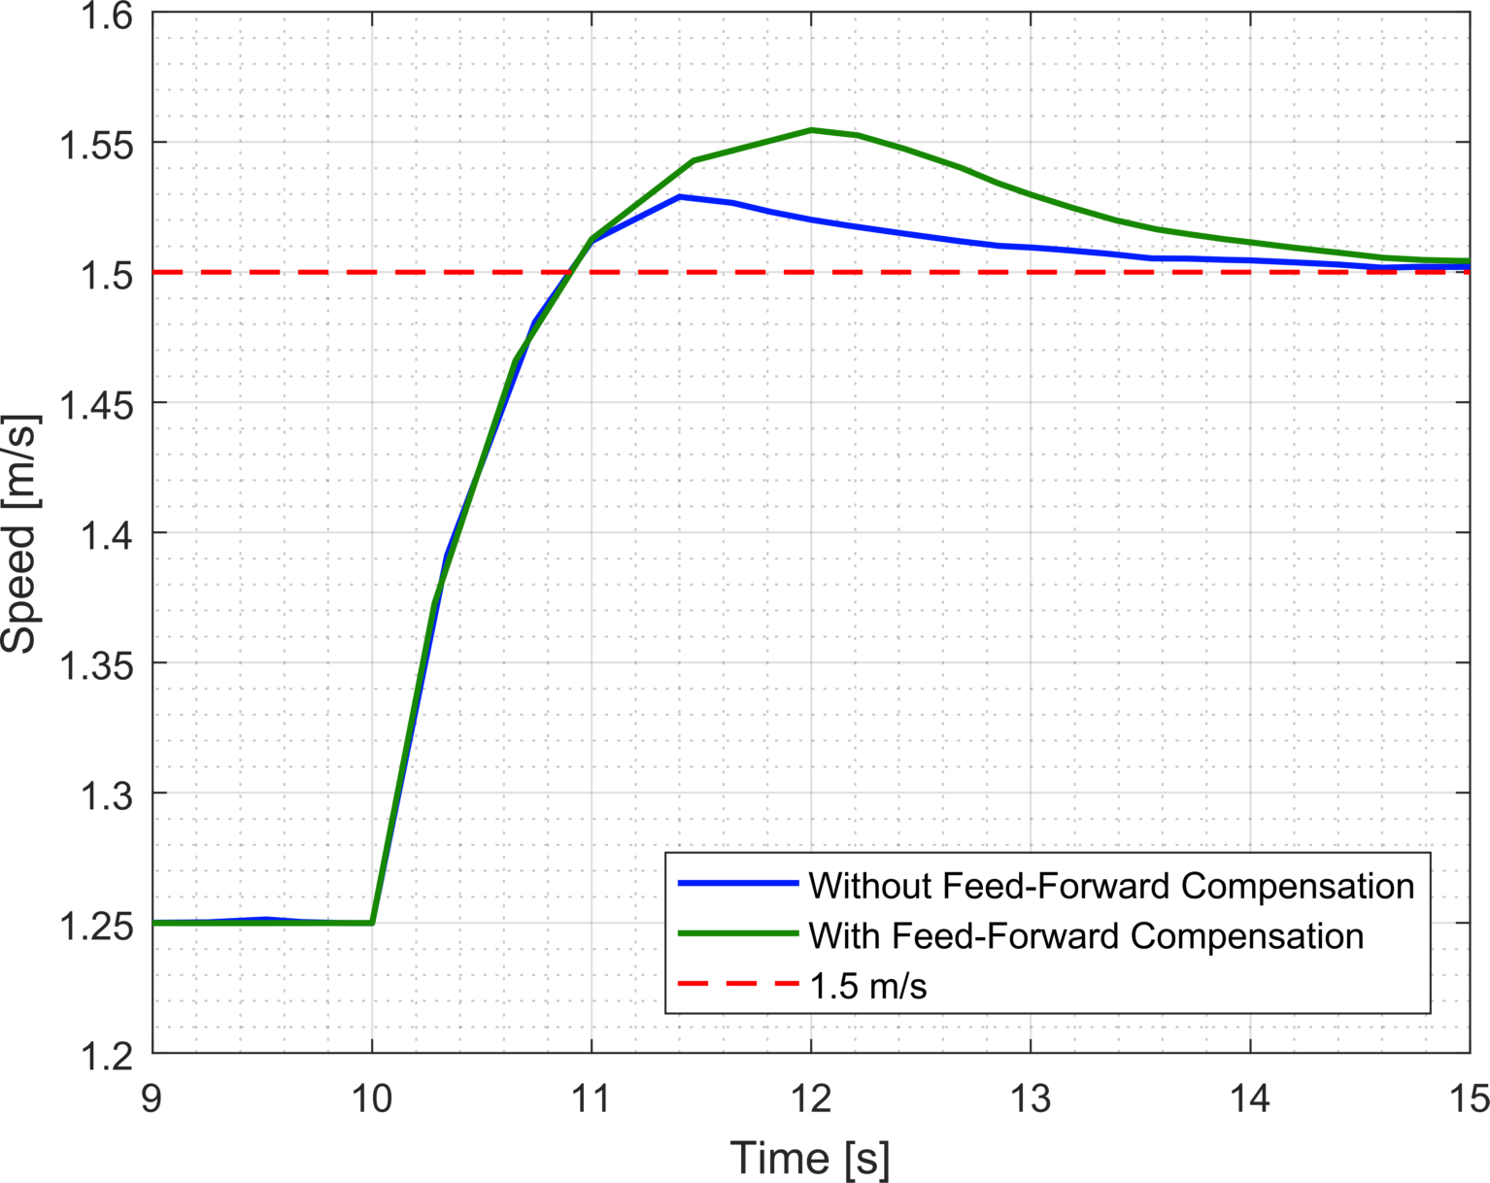

1. Optimized Step Response—High-Speed Control—Feed Forward Control

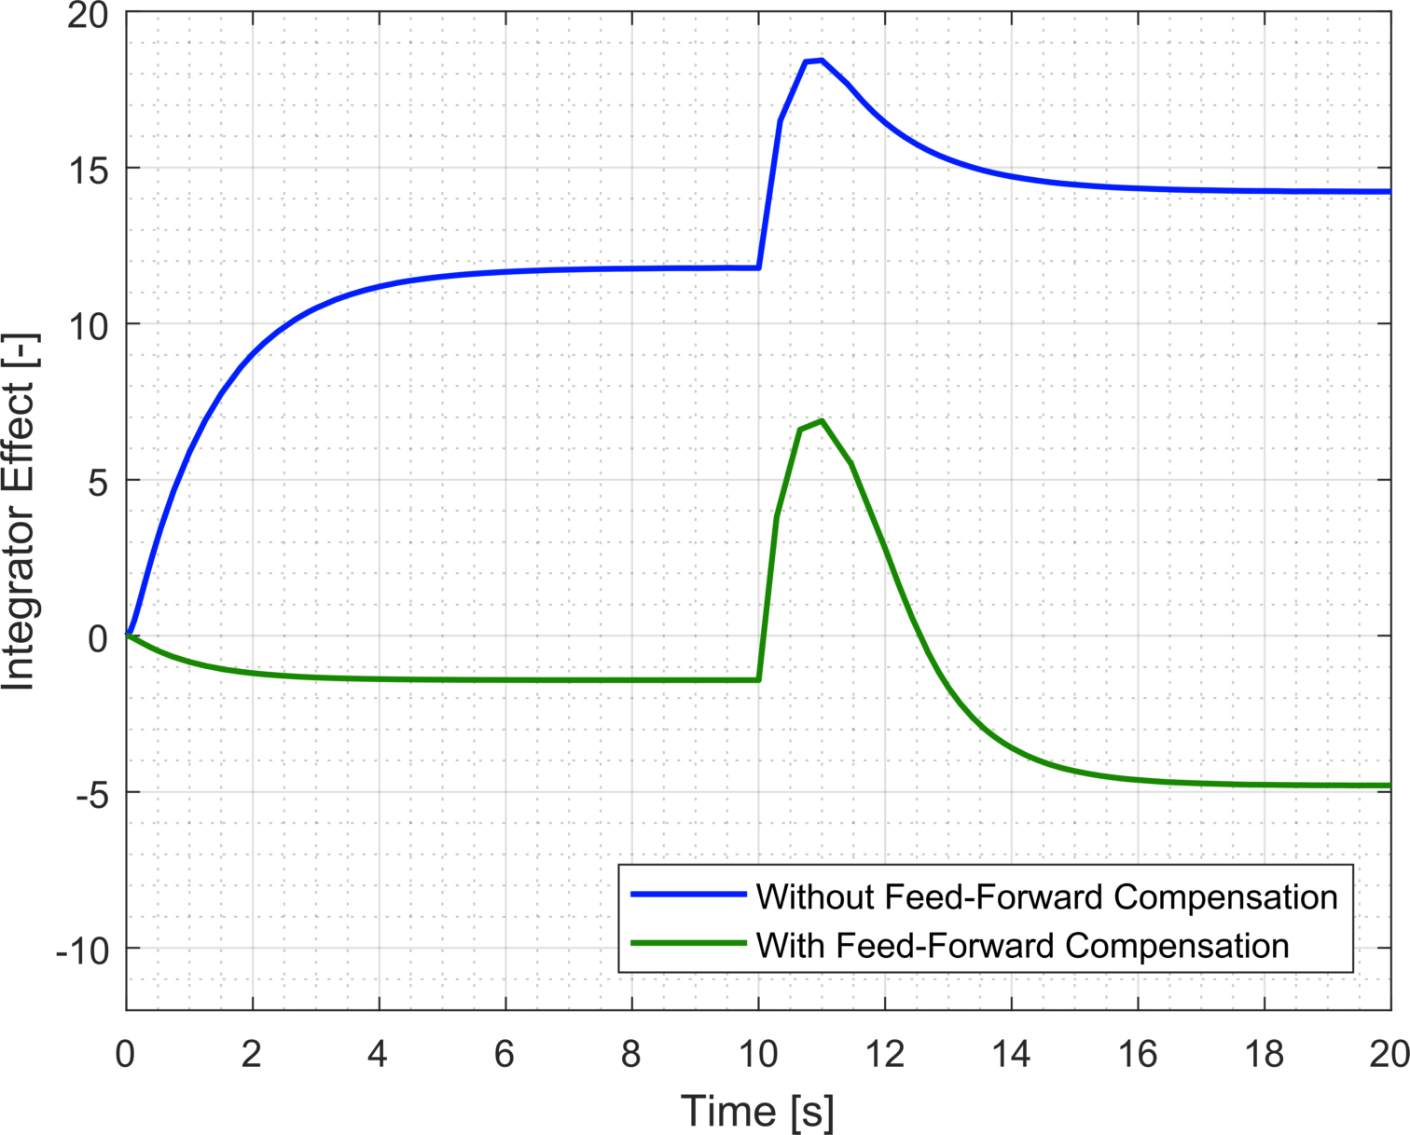

1. Optimized System Response—Feed-Forward Compensation—Integrator Effort Comparison

## simulation SUMMARY

From the simulation testing, we can draw general conclusions on the system/​model, combined controller architectures and ultimately the effects of individual techniques. Here are some of those conclusions:

1. Heading control demonstrated improved response when the PID controller was tuned in such a manner that it closely resembled a PD controller.
2. Speed control demonstrated improved response when the PID controller was tuned in such a manner that is closely resembled a PI controller.
3. A non-linear thrust model approximation demonstrated consistent improvement to base system response across all test cases. Although, its benefit was marginalized when systems were finely tuned.
4. Feed-forward compensation’s effect was minimal in the low-speed control region. It provided marginal improvement but did not demonstrate a decreased integrator effort as predicted.
5. Feed-forward compensation’s effect was significant in the high-speed control region. It allowed for significant improvement in base system response to achieve steady states at the required set-points.
6. Operating in the high-speed region, the uncompensated system was unable to effectively actuate to meet steady states at set-points in an efficient manner.
7. In contrast, the uncompensated system, when finely tuned, did demonstrate better system response in the high-speed region than its counterpart.
8. The thrust relationship utilized for the feed-forward system might be overcompensating for force at the high-speed region which requires the integrator to provide negative values inferring that it is attempting to limit the effort outputted by the controller.

Overall, the simulation provided feedback into framing expectations for the future experimental results and a basis for comparison. The controller techniques fundamentally performed as expected and more was learned about the system itself.

# experimental results and analysis

## experimental setup

### KF-USV Software and Controller Implementation

The KF-USV has an original equipment manufacturers’ (OEM) Ubuntu Linux operating computer with a Robotic Operating System (ROS) middleware installed to support remote communication and diagnostic support with the vessel. ROS is a common open-source software package in robotics and allows the KF-USV to be integrated with ROS-based sensors and/or remote networks. A ROS system architecture is based on defining a ‘ROS Master’ which allows individual pieces of software or ‘nodes’ to find and communicate with each other through the publishing or subscribing of ‘topics’ via standardized message templates. This architecture allows for the remote implementation of a low-level controller on the KF-USV vice having to code each controller in PYTHON and embedding it on the vessel. Therefore, this research utilized MATLAB and Simulink for controller design and implementation. The controller therefore reflect almost identically to what was discussed in the simulation selection with the major difference in the input and output components. Whereas the inputs and outputs affecting feedback in simulation were mathematical results from a numerical based model, the experimental controllers subscribed and published topics based on the vessel via a local wireless network. Figure 33 displays one iteration of a Simulink model used in this research utilizing this ROS based subscribe and publish technique. Using Simulink over a wireless network does have drawbacks with regards to latency issues and frequency control over messages between topics. Simulink is able to process its’ operations at a significantly faster rate than the KF-USV to receive and execute commands. Therefore, Simulink’s default solver settings are adjusted from variable-step to fixed-step with step-size limited to 0.1 correlating to a refresh rate of 10 Hz. This is an OEM designated frequency for effective use with the KF-USV. This governing of Simulink is essential in designing an effective remote controller for these low-level controllers.

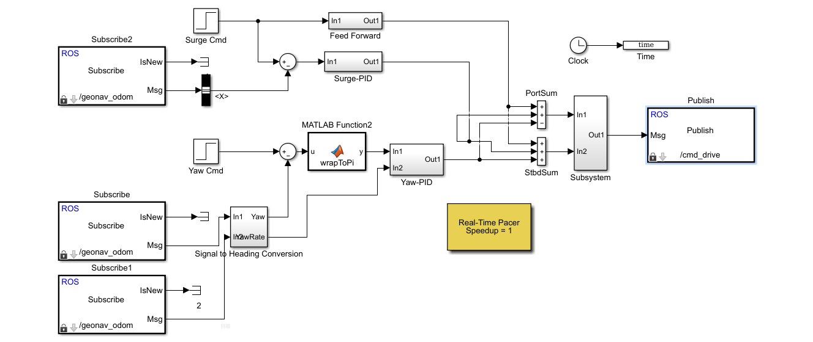

1. Simulink Model of Controller with ROS Functionality

### Sensor Integration and Feedback Management

As previously mentioned, an advantage of utilizing a ROS middleware is the integration of any sensors that have developed ROS packages (i.e., nodes, topics, messages definitions). This allows for the KF-USV to be modular and dynamic in what sensors could be integrated to support controller, path-planning, and/or guidance development. For this research, sensor-integration requirements were minimum and included only one addition from the base model. This was a LORD MicroStrain 3DM®-GX5-45 GNSS-aided inertial navigation system (INS) for positional and dynamic measurements. Equipped with its’ own Kalman filtering algorithms, it was utilized for its improved inertial measurement accuracy and advantages for sensitive control. The aforementioned Simulink controllers subscribed to the velocity, yaw and yaw rate messages for feedback control. This information also served as the basis for experimental analysis and was recorded to the MATLAB workspace. Table 17 lists the ROS nodes, topics and messages that were utilized for this research.

1. ROS Nodes, Topics and Messages of Interest for Research

|  |  |  |
| --- | --- | --- |
| Equipment (Node) | /Topic  /Message | Purpose |
| MicroStrain INS | /geonav_odom /nav_msgs/Odometry | Subscribed. Utilized for linear ‘X’ velocity (surge), heading (yaw) angle and turn rate (yaw rate). |
| KF-USV Motor Control Unit (MCU) | /cmd_drive  /kingfisher_msgs/Drive | Published. Utilized to send motor control commands [-1 to 1] for port and starboard units. |

### Test Site Locations

The experimental testing of the controller techniques with the KF-USV took place in two locations in Monterey, California. At the Naval Postgraduate School utilizing the Center for Autonomous Vehicle Research (CAVR) test tank located in Halligan Hall and at Lake El Estero with consent of local city officials.

#### CAVR Test Tank

The CAVR test tank, pictured in Figure 33, was utilized to conduct testing associated with decoupled heading control. It provides a small experimental testing location with negligible environmental effects such as wind and currents. It is 6.096 [m] long, 4.572 [m] wide, and 2.134 [m] deep and filled with freshwater but can be salinity controlled. For safety of the vessel, the KF-USV was attached to an electro-mechanical chain fall with slack placed in the chain to allow for freedom of movement but to prevent the vessel from colliding with the walls. The chain-fall caused for some inconsistencies with experimental runs as the vessel based on its dynamics inherently surges when twisting and the chain fall would retard this motion and cause oscillations to responses.

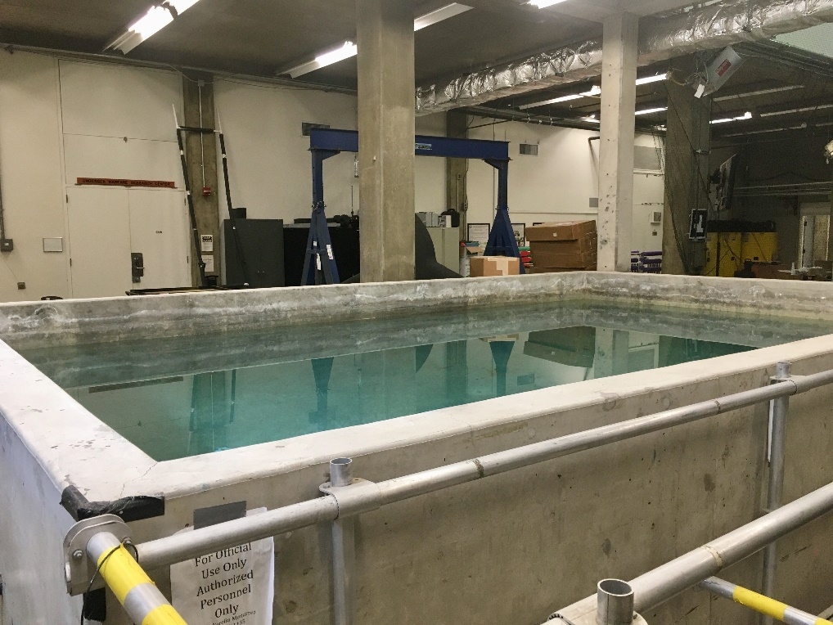

1. CAVR Test Tank

#### Lake El Estero

Lake El Estero, pictured in Figure 35, located in El Estero Park was the focus of most of the experimental testing and served as the location for decoupled speed and coupled dynamics testing. It is a freshwater lake that is approximately 240 [m] long and 47-63 [m] wide and has limited environmental effects other than sea-based wind from the nearby Pacific Ocean and wind-effect waves. It provides a relatively stable testing environment for a small sized USV vulnerable physically to overcome large environmental factors.

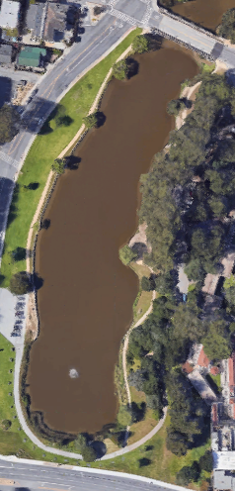

1. Lake El Estero, Monterey, California. Adapted from [21].

### Testing Apparatus and Associated Hardware

The complete testing apparatus, pictured in Figures 36-38, for experimental testing included:

1. Lenovo ThinkPad® T460 running Ubuntu Linux OS (ver. 14.04 LTS) with MATLAB R2015b with Simulink.
2. Logitech F310 Gamepad USB controller utilized for support in pre-positioning the KF-USV for trials, launching and recovering, and diagnostics.
3. CLEARPATH wireless router with antennae and adjustable tripod for extended communications.

Figure 36 is a visual overview of testing station for the research and in the background is the KF-USV in the lake which provides for a sense of scaling of the research location and vessel. Figure 37 and Figure 38 show close up perspectives on individual aspects of the testing apparatus.

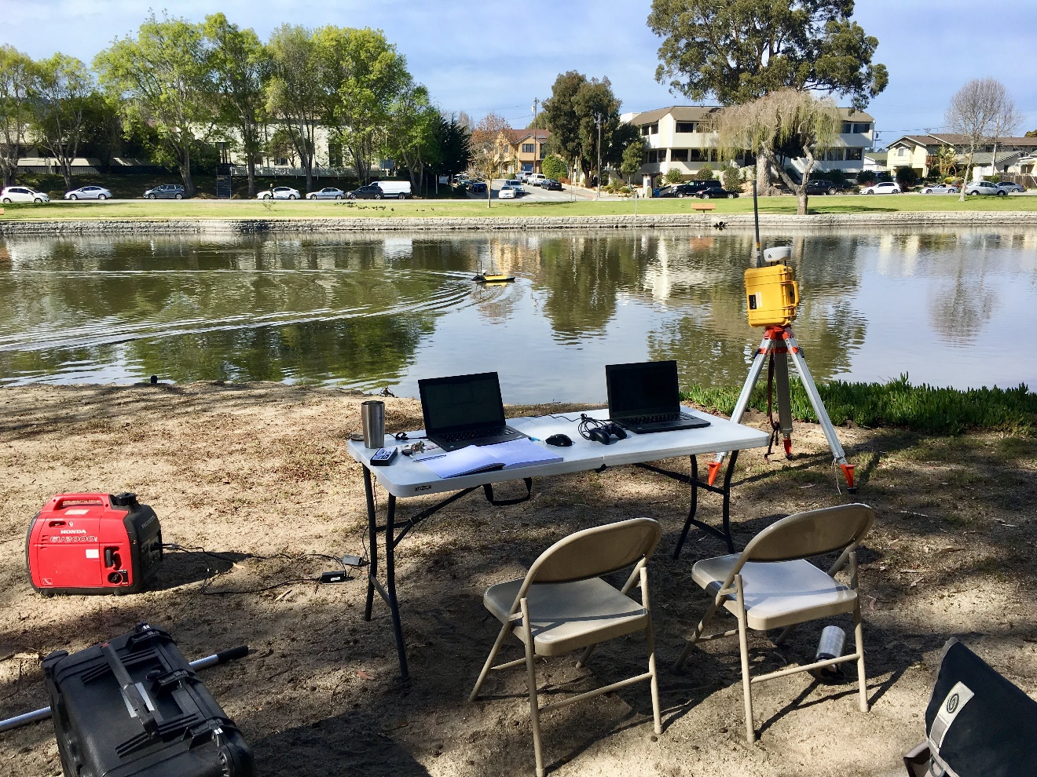

1. Lake El Estero Experimental Setup Overview

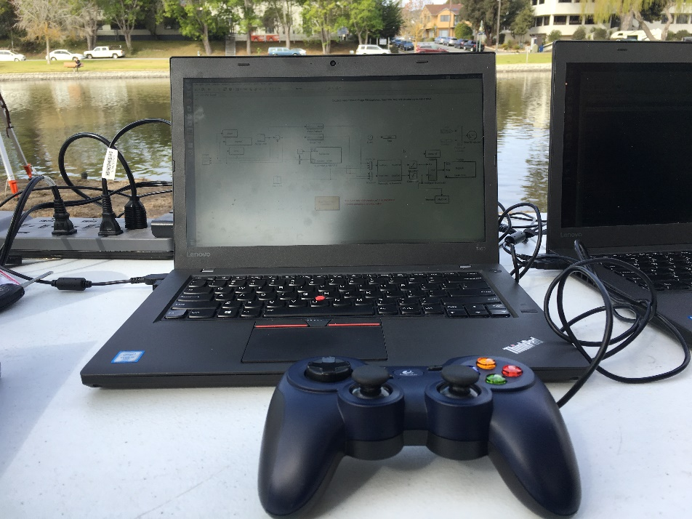

1. Lenonvo ThinkPad T460 with Logitech F310 Gamepad USB Controller.

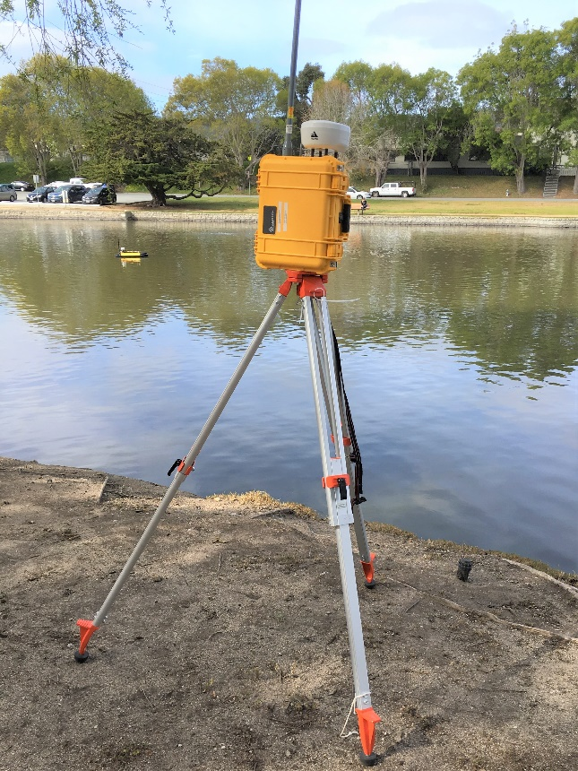

1. CLEARPATH Wireless Router and Tripod.

### Environmental Considerations

The CAVR test tank is protected from environmental effects and therefore the cause of error from winds, currents and other factors are considered negligible.

Three days were spent conducting testing at Lake El Estero; 02 February 2018, 14 February 2018 and 28 February 2018. Testing for each day was conducted between 0900-1400 (Pacific Standard Time [PST]) in constant daylight. The weather with regards to temperature (T), wind speed (average and maximum) and precipitation (P) are presented in Table 18 for each experimental session. Best attempts were made to select days of relative calm conditions to minimize the effect they made have on experimental data.

1. Selected Weather Data from Experimental Testing Days. Source: [22]

|  |  |  |  |
| --- | --- | --- | --- |
| **Date** | **Temperature**  (min/max) | **Wind Speed**  (avg/max) | **Precipitation**  (total) |
| 02/02/2018 | 10.5 / 23.9 °C  51 / 75 °F | 9.6 / 20.9 [km/h]  6.0 / 13.0 [mph] | 0.0 [cm]  0.0 [in] |
| 02/14/2018 | 7.2 / 15.6 °C  45 / 60 °F | 9.6 / 24.1 [km/h]  6.0 / 15.0 [mph] | 0.0 [cm]  0.0 [in] |
| 02/28/2018 | 10.0 / 14.4 °C  50 / 58 °F | 8.1 / 20.9 [km/h]  5.0 / 13.0 [mph] | 0.0 [cm]  0.0 [in] |

Underwater currents and other water related environmental factors were not obtained and are unknown. Lake El Estero is a relative shallow, small and isolated fresh body of water with negligible tidal shifts and therefore environmental effects were not considered as sources of error.

## experimental testing approach

In contrast to the simulation testing, the experimental testing was limited in time and ability to conduct as rigorous a tuning schedule as the latter. The experimental testing was limited to coarse tuning using good practices and changes based on visual observation. Analysis in the following sections will focus less on the tuning aspect of the controller techniques and more on the holistic effects of controller techniques on the outcome. Most of the trials that are compared are utilizing controllers that have been experimentally tuned and may vary greatly in gain magnitudes and will not account for tuning iterations.

## Decoupled dynamics

Similar to the simulation testing, the experimental testing was decomposed into analyzing the controller techniques based on their decoupled dynamics. Heading control was analyzed initially with speed control analyzed simultaneously with coupled dynamics during subsequent experiment sets at Lake El Estero.

### Heading Control

#### Assumptions and Errors Discussion

The following are assumptions and errors that effected the experimental testing of the heading control:

1. The KF-USV based on the simulation analysis was assumed to respond to a controller most closely resembling a PD controller for heading control.
2. Tuning was conducted based on visual observation and good practice for each control technique but with a standardized system as was done with simulation.
3. There was a source of experimental error with regards to the supporting chain-fall. This chain-fall, required for safety, was given enough slack (i.e., loose chain) to allow for the KF-USV to twist, free of resistance, in the tank but when surging would become taut and generate a counter force to movement on the vessel. This countering of movement on the KF-USV was observable in results as oscillatory behavior of the KF-USV attempting to correct from this force and preventing a natural progression towards a steady-state.
4. It is unavoidable because the KF-USV twists by forming moments from non-directional water jets and since the motor control units are far more effective in the forward direction than astern, there is inevitably forward surge associated with turning the KF-USV. Due to this effect and the subsequent oscillation, the settling time and steady-state error will not be utilized as metrics of comparison for this set of testing.
5. Rise time and overshoot proved useful in analysis as the response behavior of the KF-USV was consistent across trial runs and therefore are still utilized for comparison.

Figure 39 displays an example of multiple runs where the induced oscillation was present in responses around the set point.

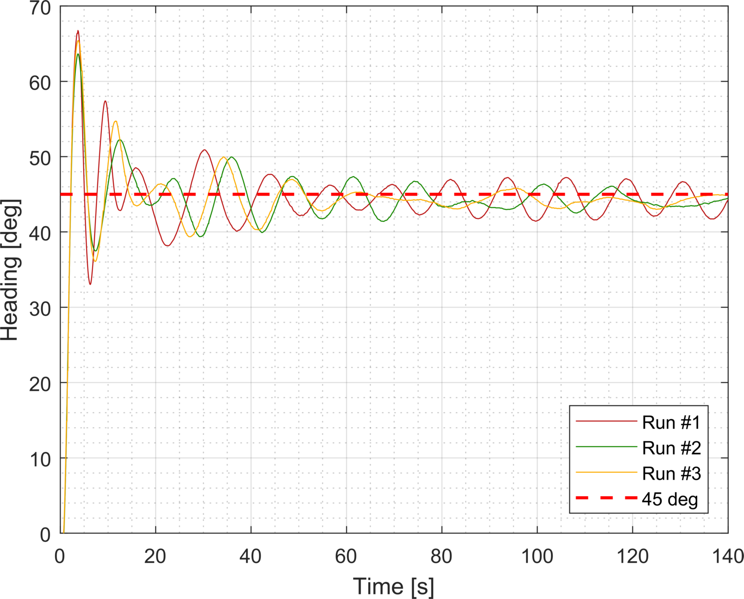

1. Experimental Heading Control – Oscillation Error Example

#### Linear and Non-Linear Thrust Model Approximations

The experimental tests were conducted identical to the simulation as 45-degree step changes. The linear and non-linear thrust model were coarsely tuned with their responses optimized to satisfy both their response to the achieving the desired set-point but also to minimize the effect of the chain-fall error. The error increases proportionally with greater surge speeds which are correlated to more aggressive turning of the vessel and therefore the responses that were optimized for these test cases may not be as aggressive (i.e., slower rise time) than ideal but provide for reasonable experimental comparison. Figure 40 displays four varied responses of the linear (top plot) and non-linear (bottom plot) thrust model approximations that have been coarsely tuned. Table 40 displays the results of the average performance characteristics not including settling time or steady state error as they were not discernible.

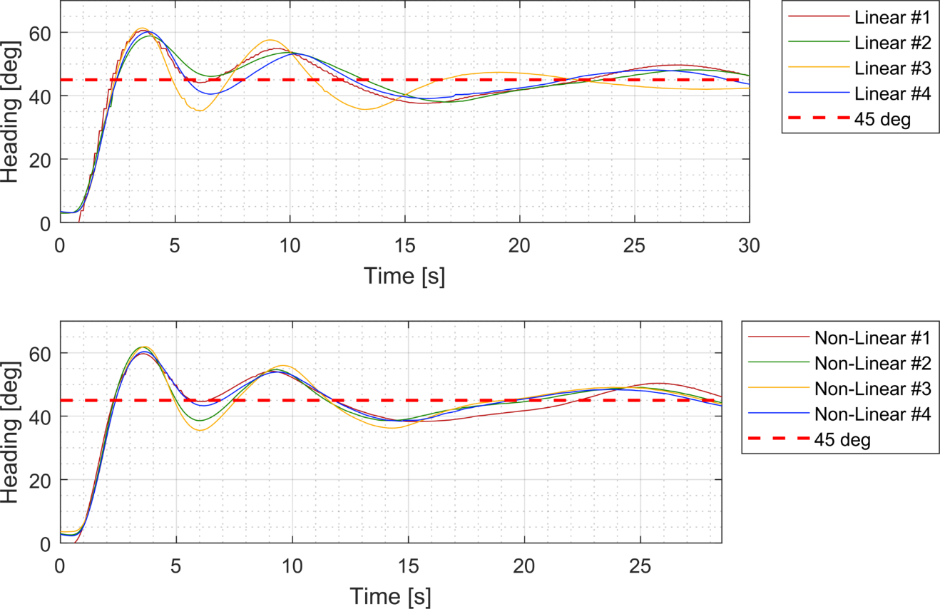

1. Heading Control – Experimental Step Responses – Linear and Non-Linear Thrust Model Approximations
2. Heading Control - Experimental Results – Performance Characteristics

|  |  |  |
| --- | --- | --- |
| **Thrust Model Selection** | **Rise Time [s] (Average)** | **Overshoot [%] (Average)** |
| **Linear** | 1.192 | 33.820 |
| **Nonlinear** | 1.142 | 35.429 |
| **Difference** | 0.050 | -1.610 |

From the results, we can ascertain the following conclusions:

1. The responses demonstrate near identical behavior and response shape when tuned.
2. The non-linear thrust model visually performs with more consistency in overall form.
3. The non-linear thrust model provides nominal improvement in rise time indicating a quicker adaptation to set-point shift but consistently demonstrated slightly more overshoot.

### Speed Control

The basis of decoupled speed control testing was identical to the simulation testing. This was to analyze a the closed-loop response to a low-speed (0.0 to 0.25 [m/​s]) and high speed (1.25 to 1.50 [m/​s]) step response independently while implementing each of these speed regions with and without a feed-forward component and with either a linear or non-linear thrust model approximation. The goal of the experimental testing was to identify the effect of each control technique in a real-world setting.

#### Assumptions and Error Discussions

The following are assumptions and errors that effected the experimental testing of the heading control:

1. The KF-USV based on the simulation analysis was assumed to respond to a controller most closely resembling a PI controller for speed control.
2. Tuning was conducted based on visual observation and good practice for each control technique but with a standardized system as was done with simulation.
3. There was a source of experimental error with regards to sensor information provided by the IMU. Depending on satellite positional information, there would be disruptions in this information stream causing undesired responses from the controller.
4. Maintaining a relatively low speed of 0.25 [m/s] was experimentally difficult for the vessel as sensitivity as it is to small changes in the environment. This difficulty manifests itself in noisy responses when near the steady state.
5. Based on physical constraints of the lake, trial durations for the high-speed runs were limited to prevent colliding with the shore and walls. This limits analysis of steady-state and settling times in some of the trials.
6. Rise time and overshoot proved useful in analysis as the response behavior of the KF-USV was consistent across trial runs and therefore are consistently utilized for comparison. Where accurate settling time, percent overshoot and steady state error are also included into analysis.

#### Low Speed Control

The low speed control region was tested with respect to comparison of thrust models and with regards to the utilization of feed-forward compensation.

##### Linear versus Non-Linear Thrust Model Comparison

First, the linear and non-linear thrust models were compared with the tuned responses plotted in Figure 41 and key performance characteristics identified in Table 20. The following are observations with regards to their responses:

1. The linear and non-linear thrust models produce near identical responses.
2. The non-linear thrust model produces slightly improved performance response in regards to rise and settling time and percent overshoot.
3. Both responses achieve zero steady state error with little difficulty.

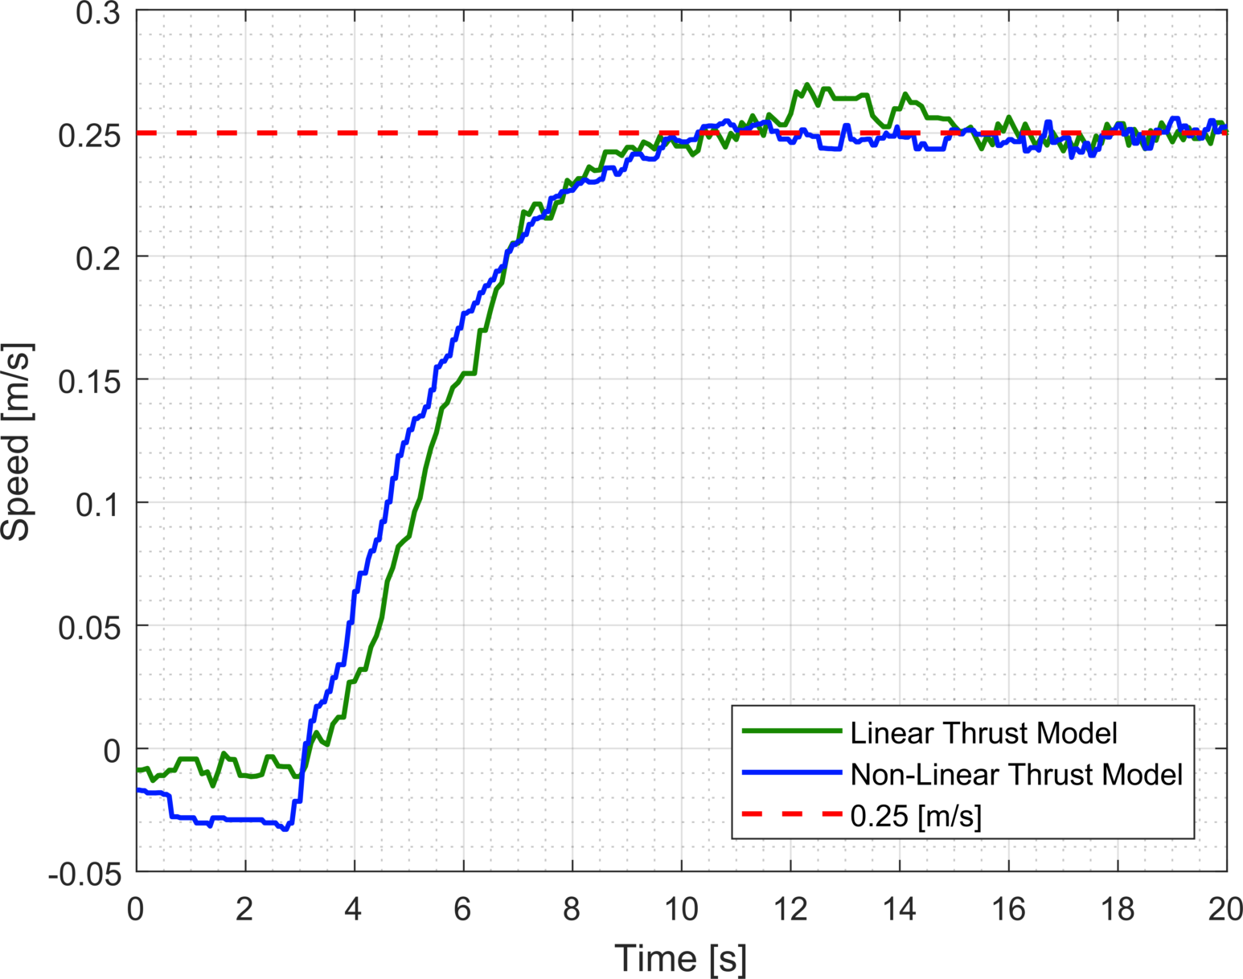

1. Optimized Experimental Step Responses – Low Speed Control –Linear and Non Linear Thrust Model Approximations
2. Optimized Experimental Performance Characteristics Comparison—Low-Speed Control—Linear and Non-Linear Thrust Model Approximations

|  |  |  |  |  |  |  |  |  |  |  |
| --- | --- | --- | --- | --- | --- | --- | --- | --- | --- | --- |
| **Gains** | | ***Rise Time, TR* [s]** | | | ***Settling Time, TS*[s]** | | | ***Steady State Error [m/​s]*** | | |
| **Kp**  (L/​NL) | **Ki**  (L/​NL) | **L** | **NL** | **Δ[s]** | **L** | **NL** | **Δ[s]** | **L** | **NL** | **Δ[m/​s]** |
| 24/40 | 10/​15 | 3.99 | 4.41 | **0.42** | 9.11 | 5.41 | **3.70** | 0.00 | 0.00 | **0.00** |

##### Feed-Forward Compensation

The KF-USV was tested with and without the use of a feed-forward term. This term’s relationship is identical to the simulation model and is presented again in Equation (11).



The basis of comparison for this testing is the non-linear thrust model approximation. In addition to observing the step-response and accompanying characteristics, the integrator’s effort was also recorded for analyzing effect of integrator wind-up similar to the simulation-based testing. Figure 42 and Table 21 present the results of the tuned response for each system graphically and in the form of key performance characteristics. From these results we observe the following:

1. The feed-forward compensation provides significant improvement in rise time. This can be expected based on its’ instantaneous thrust command boost based on set-point to the motor control unit.
2. The feed-forward did over-compensate and produce significant overshoot but with limited time for tuning; could have been minimized through refinement.
3. The integrator for the feed-forward compensation produced results attempting to minimize the impact of the rest of the controller’s effort.
4. Optimized Experimental Performance Characteristics—Low-Speed Control—Feed-Forward Compensation

|  |  |  |  |  |  |  |  |  |  |  |
| --- | --- | --- | --- | --- | --- | --- | --- | --- | --- | --- |
| **Gains** | | ***Rise Time, TR* [s]** | | | ***Settling Time, TS*[s]** | | | ***Steady State Error [m/​s]*** | | |
| **Kp**  (NF/​FF) | **Ki**  (NF/​FF) | **NF** | **FF** | **Δ[s]** | **NF** | **FF** | **Δ[s]** | **NF** | **FF** | **Δ[m/​s]** |
| 40/80 | 15/25 | 4.40 | 0.34 | **4.06** | 5.41 | 24.2 | **18.79** | 0.00 | 0.00 | **0.00** |

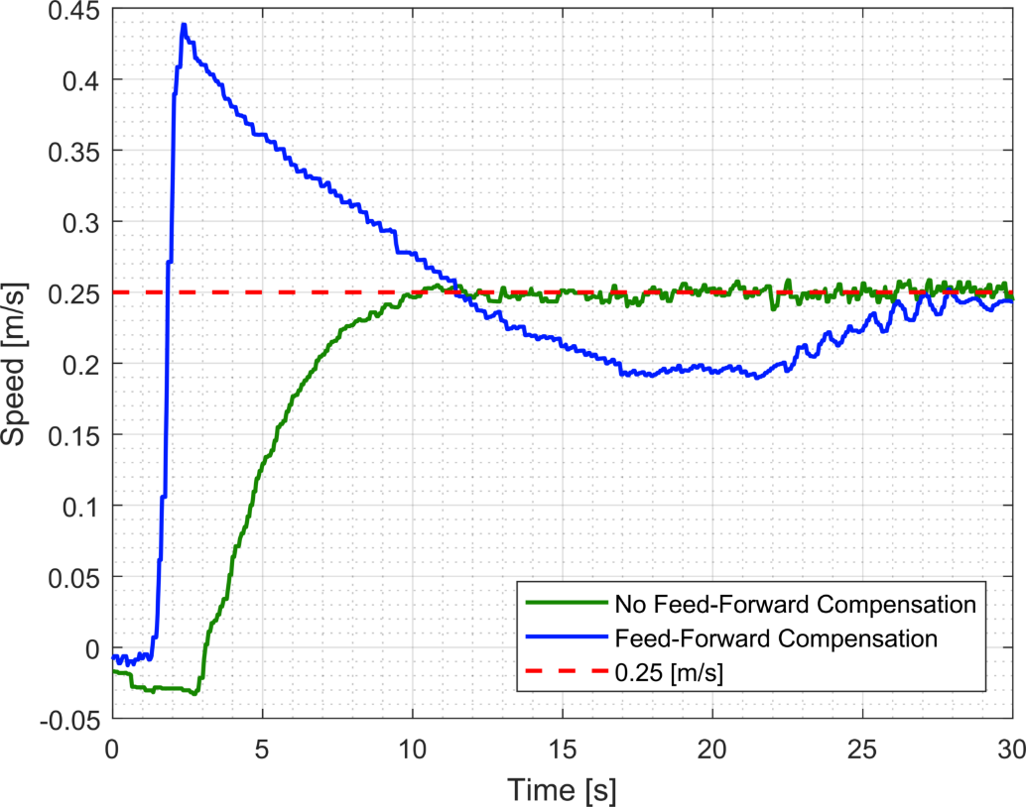

1. Optimized Step Response—Low-Speed Control—Feed Forward Control

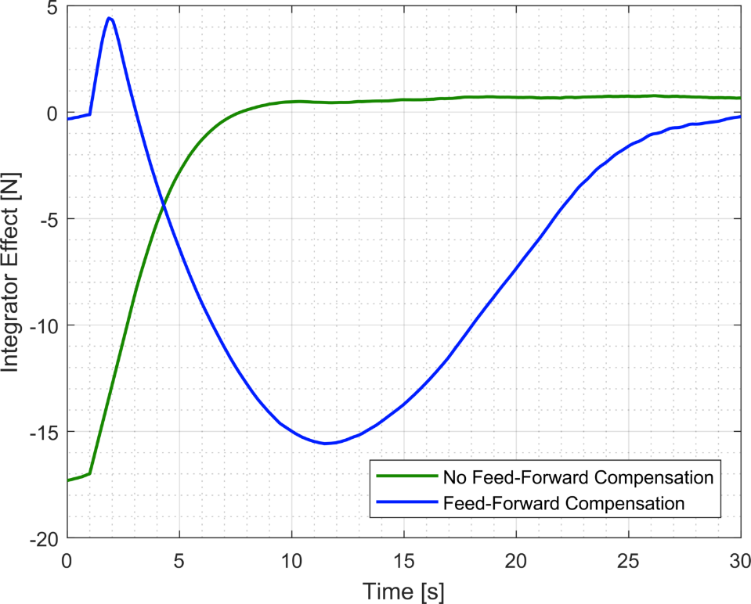

1. Optimized System Response—Feed-Forward Compensation—Integrator Effort Comparison

#### High Speed Control

The high speed control region was tested with respect to comparison of thrust models and with regards to the utilization of feed-forward compensation.

##### Linear versus Non-Linear Thrust Model Comparison

First, the linear and non-linear thrust models were compared with the tuned responses plotted in Figure 44 and key performance characteristics identified in Table 22. Due to limited trials conducted for this speed region for this test case, there are two responses plotted for the non-linear thrust model to show uncertainty in what might constitute an idea response. The following are observations with regards to their responses:

1. The linear and non-linear models exhibit varied responses but this may be due to lack of proper tuning associated with the non-linear thrust response.
2. Both response trends towards zero steady state error and exhibit similar initial response behavior.
3. This testing would require more trials to accurately identify trends associated with it.

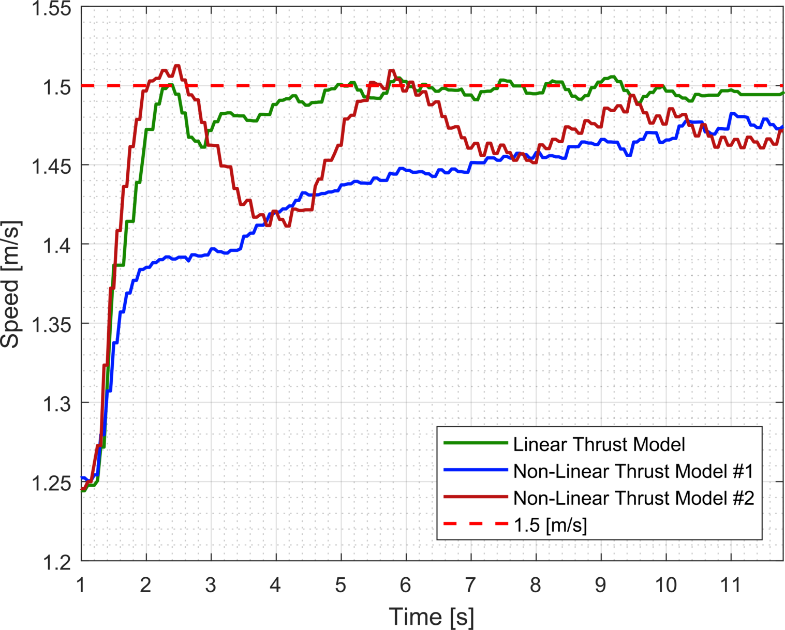

1. Optimized Experimental Step Responses – High Speed Control –Linear and Non Linear Thrust Model Approximations
2. Optimized Experimental Performance Characteristics Comparison—High-Speed Control—Linear and Non-Linear Thrust Model Approximations

|  |  |  |  |  |  |  |  |  |  |  |  |
| --- | --- | --- | --- | --- | --- | --- | --- | --- | --- | --- | --- |
| **Gains** | | | ***Rise Time, TR* [s]** | | | ***Settling Time, TS*[s]** | | | ***Overshoot [%]*** | | |
| **Trial** | **Kp** | **Ki** | **L** | **NL** | **Δ[s]** | **L** | **NL** | **Δ[s]** | **L** | **NL** | **Δ[%]** |
| L / NL #1 | 40 / 24 | 15 / ​10 | 0.75 | 9.82 | **9.07** | 3.61 | 10.07 | **6.46** | 0.00 | 0.00 | **0.00** |
| L / NL #2 | 40 / 40 | 15 / 15 | 0.75 | 0.54 | **0.21** | 3.61 | 12.12 | **8.51** | 0.00 | 1.02 | **1.02** |

##### Feed-Forward Compensation

The KF-USV was tested with and without the use of an identical feed-forward term as the low-speed and simulation testing. The basis of comparison for this testing is the non-linear thrust model approximation. Figure 45 and Table 23 present the results of the tuned response for each system graphically and in the form of key performance characteristics. In addition to conducting the similar comparison as the low-speed control, testing was also conducted to compare a system with a proportional only ‘P’ controller with a feed-forward term versus one with a PI controller and feed forward. Figure 46 plots the two responses, one with no integrator and one with a minimal integrator gain to identifies trends related to the compensation generated. In addition to this and the previous step response comparison, the effect of the integrators is displayed in Figure 47. From these results we observe the following:

1. The tuned feed forward and non-feed forward systems produced similar responses and performance characteristics.
2. The feed-forward term nearly negates the need for the integrator to produce any effort as is indicated in Figure 47.
3. Optimized Experimental Performance Characteristics—High-Speed Control—Feed-Forward Compensation

|  |  |  |  |  |  |  |  |  |  |  |
| --- | --- | --- | --- | --- | --- | --- | --- | --- | --- | --- |
| **Gains** | | ***Rise Time, TR* [s]** | | | ***Settling Time, TS*[s]** | | | ***Steady State Error [m/​s]*** | | |
| **Kp**  (NF/​FF) | **Ki**  (NF/​FF) | **NF** | **FF** | **Δ[s]** | **NF** | **FF** | **Δ[s]** | **NF** | **FF** | **Δ[m/​s]** |
| 40/80 | 15/25 | 4.40 | 0.34 | **4.06** | 5.41 | 24.2 | **18.79** | 0.00 | 0.00 | **0.00** |

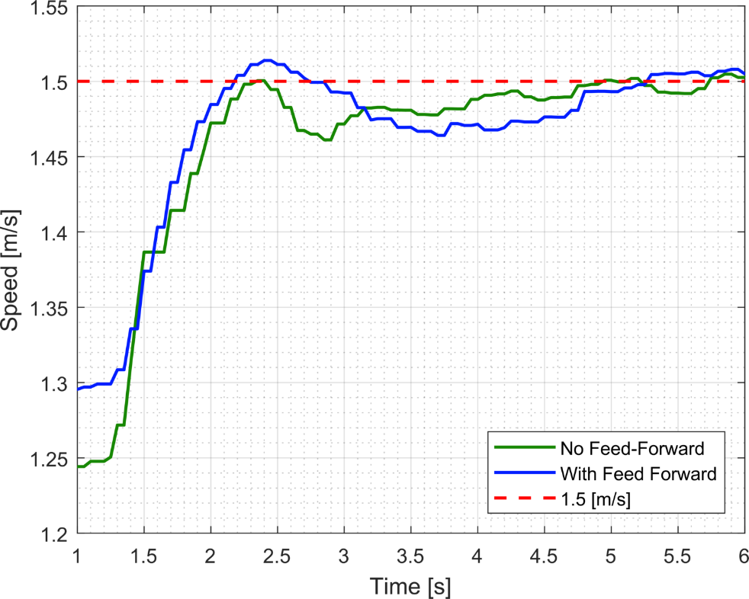

1. Optimized Step Response—High Speed Control—Feed Forward Control

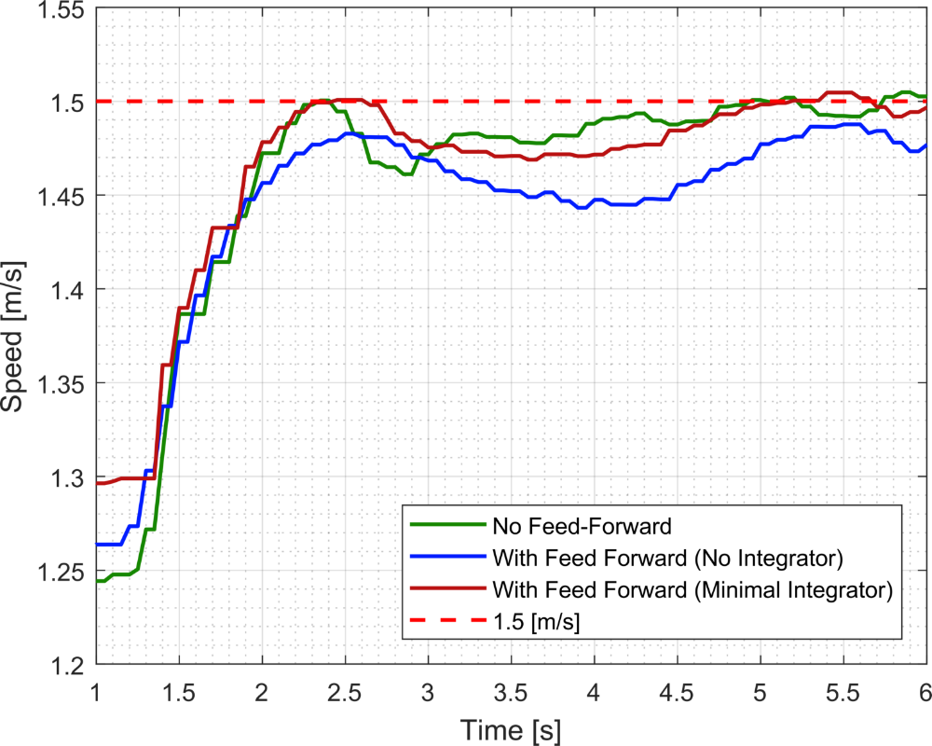

1. Optimized Experimental Step Responses – High Speed Control – Feed Forward Control Integrator Analysis

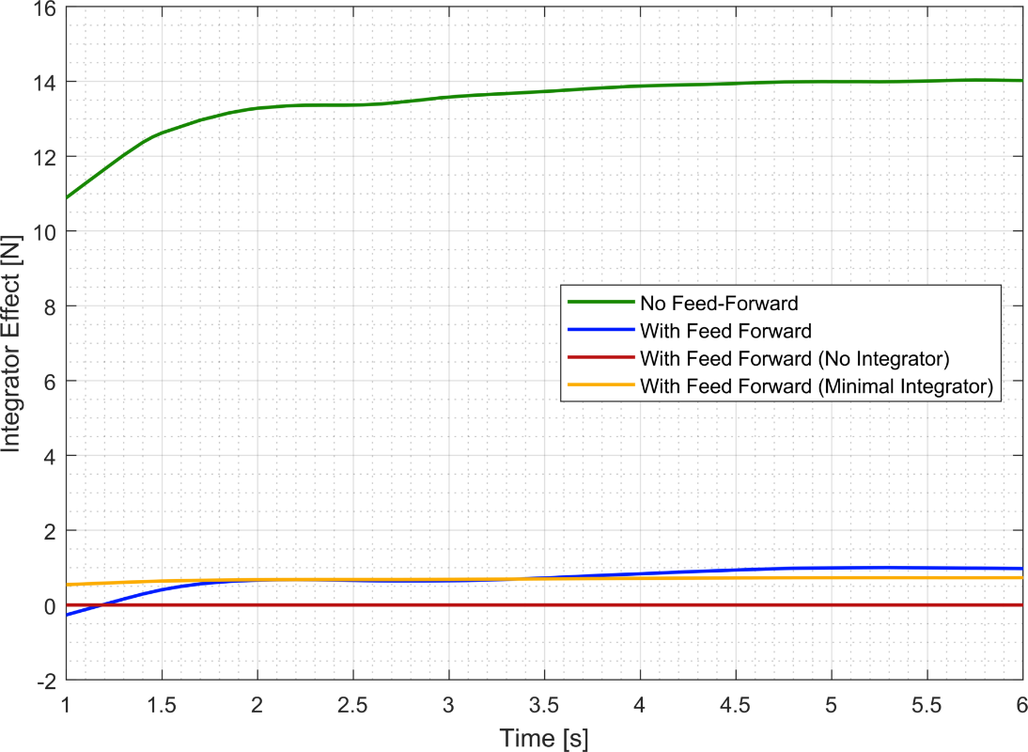

1. Optimized System Response—Feed-Forward Compensation—Integrator Effort Comparison

## coupled dynamics

For coupled dynamics, the KF-USV was tested conducting a 45 degree turn at a low speed, 0.25 [m/s], steady state and also at a high speed, 1.25 [m/s], steady state. The systems were tested to analyze the effects of linear and non-linear thrust models approximations, feed forward compensation and combined configurations on heading and speed control through the maneuver.

#### Low Speed Turn

The low speed turn was tested with respect to comparison of thrust models and with regards to the utilization of feed-forward compensation. Figure 48 displays tuned step response for the heading change and subsequent response to the speed of the vessel on the top and bottom plots respectively. Also, key performance characteristics for heading step responses are identified in Table 24. With each case for the low speed turn presented, the following are observations based on these responses:

1. All configurations produce very similar responses to the step change in heading.
2. Heading change caused surging in the vehicles speed for all response. The speed controller then worked to the return to the steady state set-point.
3. All responses eventually returned to steady state values for heading and speed respectively.

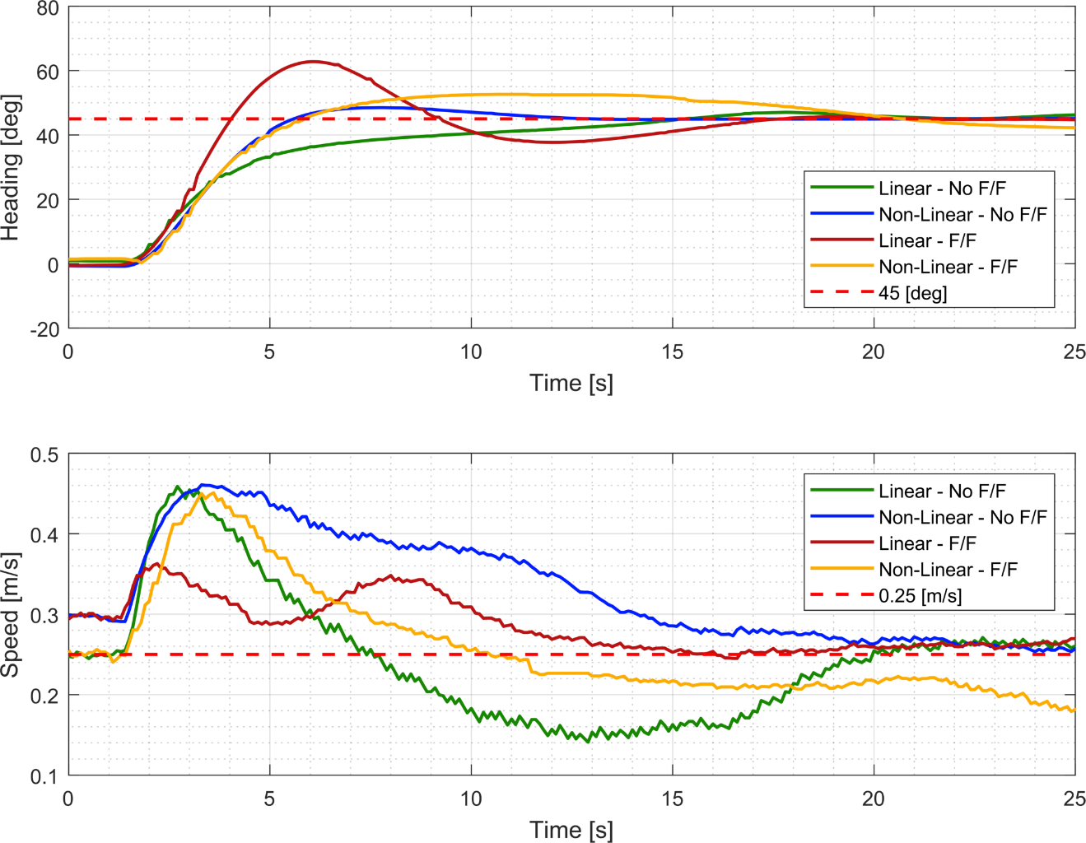

1. Optimized Experimental System Responses – Low Speed Turn – Coupled Dynamics
2. Optimized Experimental Performance Characteristics Comparison—Coupled Dynamics – Heading Response at Low Speed

|  |  |  |  |  |  |
| --- | --- | --- | --- | --- | --- |
| **Heading Controller Gains** | | | ***Rise Time, TR* [s]** | ***Settling Time, TS*[s]** | ***Overshoot [%]*** |
| **Case** | **Kp** | **Kd** | **L** | **L** | **L** |
| Linear / No Feed Forward | 12.5 | 5 | 8.1727 | 13.2113 | 6.7935 |
| Non-Linear / No Feed Forward | 12.5 | 5 | 2.8103 | 11.3536 | 7.7805 |
| Linear / Feed Forward | 12.5 | 5 | 1.8089 | 14.2229 | 39.5363 |
| Non Linear Feed Forward | 12.5 | 5 | 2.7116 | 18.0125 | 16.9660 |

Additionally, the integrator effect on the speed control was recorded and is plotted in Figure 49. In contrast to all previous tests, the integrator effect did not follow the trend of reducing the effect of the integrator with the same configuration. With the linear thrust model as a basis, the integrator effect is smaller without the feed-forward. While, the non-linear thrust model demonstrates the same behavior as previous tests with the integrator effect being reduced by the feed-forward compensation.

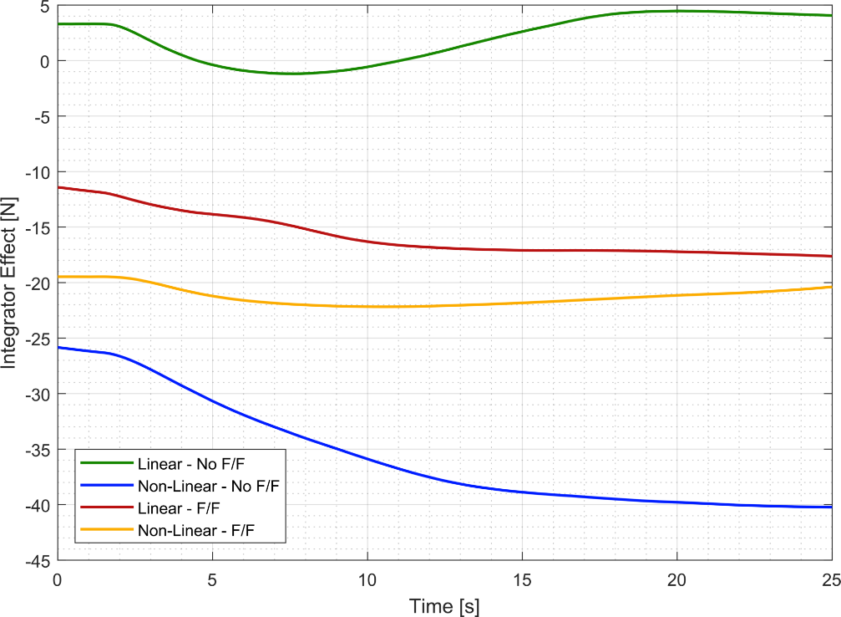

1. Optimized Experimental System Response—Low Speed Turn - Compensation—Integrator Effort Comparison

#### High Speed Turn

The high speed turn control region was tested with respect to comparison of thrust models and with regards to the utilization of feed-forward compensation. Figure 50 displays tuned step response for the heading change and subsequent response to the speed of the vessel on the top and bottom plots respectively. Also, key performance characteristics for heading step responses are identified in Table 25. With each case for the low speed presented, the following are observations based on these responses:

1. All configurations produce very similar responses to the step change in heading.
2. Feed forward compensation decreased rise time and increased overshoot in the system.
3. All responses eventually returned to steady state values for heading and speed respectively.
4. Linear and nonlinear thrust model approximations produced near identical responses.

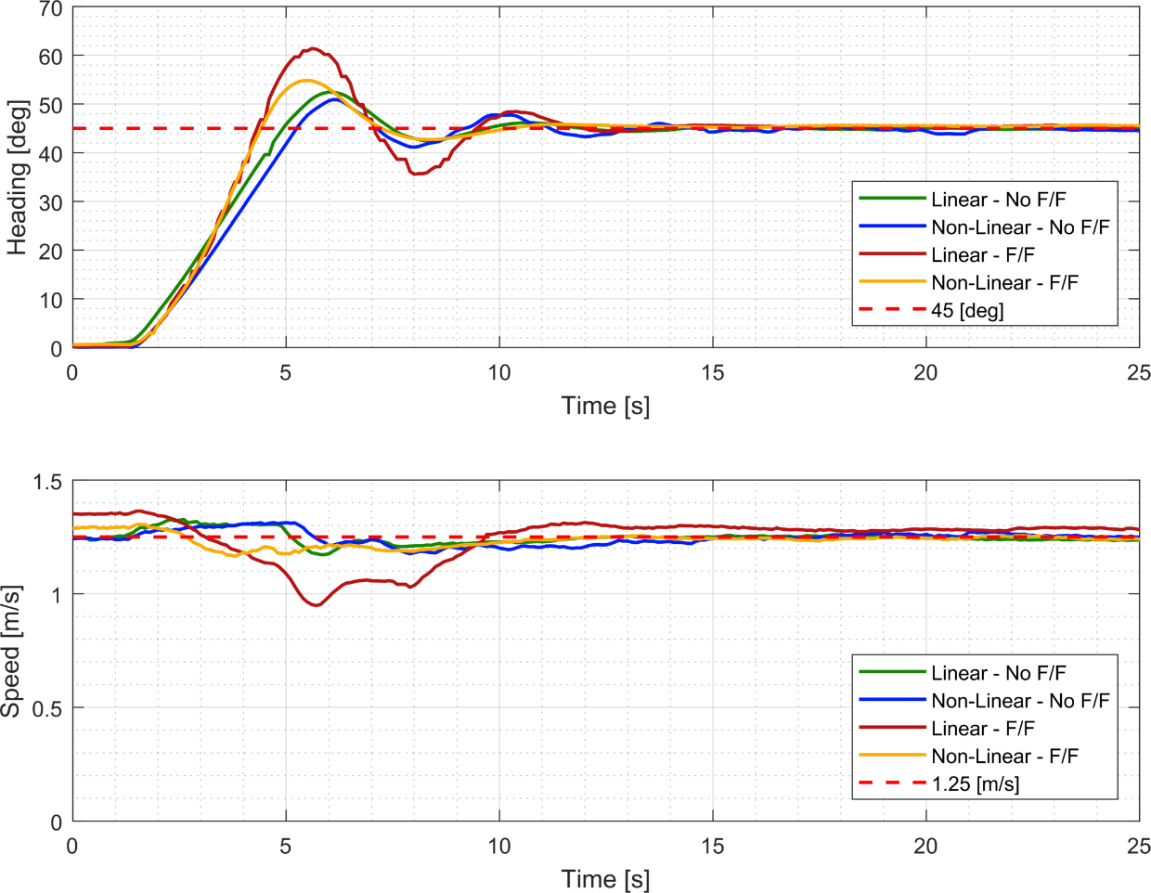

1. Optimized Experimental System Responses – Low Speed Turn – Coupled Dynamics
2. Optimized Experimental Performance Characteristics Comparison—Coupled Dynamics – Heading Response at Low Speed

|  |  |  |  |  |  |
| --- | --- | --- | --- | --- | --- |
| **Heading Controller Gains** | | | ***Rise Time, TR* [s]** | ***Settling Time, TS*[s]** | ***Overshoot [%]*** |
| **Case** | **Kp** | **Kd** | **L** | **L** | **L** |
| Linear / No Feed Forward | 75 | 15 | 2.9071 | 11.1804 | 16.5730 |
| Non-Linear / No Feed Forward | 75 | 15 | 2.9174 | 11.2301 | 13.1412 |
| Linear / Feed Forward | 100 | 20 | 2.1593 | 11.4816 | 36.4143 |
| Non Linear Feed Forward | 50 | 12 | 2.1560 | 9.6293 | 21.7687 |

Additionally, the integrator effect on the speed control was recorded and is plotted in Figure 51. The integrator effect followed the consistent trend of reducing the effect of the integrator with the same configuration. With the linear thrust model and non-linear thrust model approximations as the basis, respectively, the integrator effect is decreased with the inclusion of feed-forward compensation. While, the non-linear thrust model demonstrates the same behavior as previous tests with the integrator effect being reduced by the feed-forward compensation.

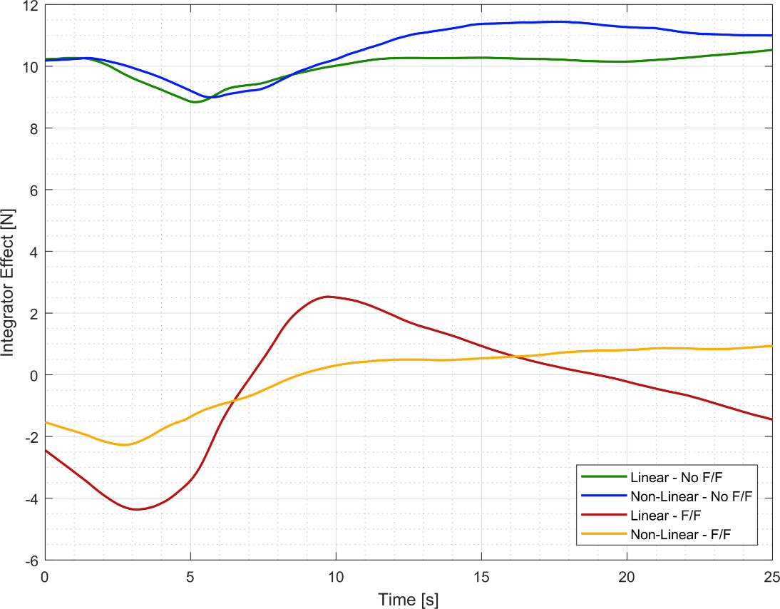

1. Optimized Experimental System Response—Low Speed Turn - Compensation—Integrator Effort Comparison

## experimental SUMMARY

From the experimental testing, we are able to draw conclusions and observations that are critical to the real-world application of these controllers in this specific application. Here are some of those conclusions:

1. Heading control and tuned response was near identical for the linear and non-linear thrust model approximations.
2. Speed control demonstrated difficulty in maintain steady state around the low speed set-point of 0.25 [m/s]. This may be attributed to the following factors:
3. Sensitivity at low speed to external forces and motions generated from environmental factors, e.g., winds and currents, and the resulting forces.
4. Overcoming dead-band issues near zero velocity and the ability to generate small changes in thrust for velocity control.
5. Sensor accuracy from IMU for accurate velocity inputs around the datum.
6. Feed forward compensation benefitted the system at the high speed region providing decreases in rise time but usually with the trade of increases in overshoot for similar tuning requirements.
7. Feed forward, with the exception of the low-speed turn, minimized the effect of the integrator portion of the speed controller.
8. The system conducted high-speed and low-speed turns efficiently with regards to the heading control.
9. Low-speed turns caused surging in the velocity at least partially due to the physics of having non-directional thrusters to generate any turn and not having any other control surface to generate the moments required.
10. High-speed turns produced more efficient speed consistency through the turn but had the reverse effect of losing, vice gaining, speed through turns.

Overall, the experimental results provided vital feedback for the implementation of these controllers into the KF-USV. It allowed for analysis of the controllers similar to the simulation but that also included uncontrollable and varied external forces effecting results. Further conclusions and discussions will compare these results to the simulation.

THIS PAGE INTENTIONALLY LEFT BLANK

# CONCLUSION(S)

The fundamental basis of this research was to test how a low-level controller benefits with leveraged knowledge of the model applied to a small USV’s heading and speed control. This was done by developing simple decoupled models for speed (surge) and heading (yaw) applying a PID controller for feedback control for each motion. Then used concepts and theory related to command-compensated control and thruster model selection importance to develop control techniques for comparison. These were implemented through:

1. The use of a feed-forward term (command-compensated) for speed control based on an estimated relationship between commanded speed and thrust force requirements.
2. The use of an improved non-linear thruster model based on previous experimentation relating thrust force generated by the KF-USV to motor commands in comparison to a linearly developed relationship based on max thrust generation over motor command range.

These individual techniques have known effects on similar systems but this research was conducted in order to attempt to answer the following:

1. Objectively evaluate the advantages of the inclusion of these controller techniques to the overall response in specified tests.
2. Objectively and subjectively make observations on the trade-offs on the effort required to develop model base controller techniques versus the real outcomes of their implementation.

## simulation and experimental comparison

The approach of this research involved establishing a numerical baseline to the decoupled motions and the effects of the individual controller techniques in simulation and then to conduct experimental testing for comparison. Chapters 3 & 4 documented in the results of the controller techniques across the array of test cases in their respective testing domain. The following observations are highlighted to establish differences that are of particular concern to future controller development and basis for later improvements:

1. Simulation-based controllers for speed and heading control, when tuned, resulted in gain constants that are very similar for both speed regions. This implies that one controller can be tuned and effective over the entire speed domain. In contrasts, gain constants varied significantly for the experimental controllers when implemented implying that gain scheduling could be a useful real-world technique for effective control.
2. Simulation and experimental results varied significantly in the low-speed region where the numerical model does not deal with the physical and inherent difficulties of executing low-speed maneuvers against environmental factors, variation in sensor information, and differentiating small motor commands.
3. Experimental results have significantly slower rise and settling times when compared to simulation which can be attributed to an imperfect drag and hydrodynamic model for the KF-USV and latency issues with the feedback control. The latency issues derive from the communication chain of sensor information received via network to the computer, computational processing of the controller, publishing of command to KF-USV, and translation of command to physical output.
4. There were significantly less experimental results based on time and resources than the magnitude of simulation trials and tests conducted. This could result in the ability to correlate trends in results between the two domains for common test cases.
5. There is a lack of quantifiable tuning requirements for a comparison in the simulation and experimental domains. This inability to conduct a robust or methodical tuning system, as was done simulation, does not allow a metric to compare the tuning of the

## controller technique benefits analysis

Despite the differences in the simulation and experimental results, there was still enough testing between the two to establish a basis for making conclusions for the benefits of utilizing model-based knowledge to improve low-level controllers. The following are conclusions based on the questions and intent of this research:

1. The utilization of a non-linear thrust model in this particular application to improve the speed and/or heading control is of negligible improvement. Therefore, time could be saved in robust testing of mapping specific thrust outputs over a range of motor commands to simply calculating a maximum thrust and linearly approximating.
2. The utilization of a command-compensated term in the form of a feed-forward relationship between commanded speed and thrust force was beneficial enough to overall performance. It consistently decreased rise time and was specifically advantageous in the high-speed region of performance. It also provided observable benefits to maintain speed through the low and high speed terms for the coupled dynamics. Albeit, it often increased overshoot in the step response so that should be a consideration based on application.
3. Overall tuning requirements of these controller techniques in simulation and experimentally to obtain optimized results was negligible in this authors opinion. Both systems tuned with similar effort and therefore do not decrease the work requirement associated with controller implementation.

## proposal for future studies

Future work for this study would include:

1. Developing a more accurate speed and thrust relationship to increase the benefits achieved from the feed-forward compensation.
2. Investigating other controller techniques such as L1 and/or model-reference adaptive controllers (MRAC) and conducting similar comparison studies.
3. Conduct tank testing of the KF-USV and identify hydrodynamic properties and coefficients to improve the model and therefore improve the accuracy of comparing results from simulation to experimental.

THIS PAGE INTENTIONALLY LEFT BLANK

# List of References

[1] J. Katz, “Navy seeks to advance DARPA’s sub-tracking USV technology in FY-19,” *Inside the Pentagon’s Inside the Navy,* vol. 31, no. 9*,* 2018. [Online]. Available: https://search.proquest.com/​docview/​2010313127



[2] Megan Eckstein, “Navy Racing to Test, Field Unmanned Maritime Vehicles for Future Ships,” *USNI News,* Sep 21, 2017.

[3] Office of Secretary of Defense, “Unmanned systems roadmap (2007-2032),” Department of Defense, Dec 10, 2007.

[4] S. Kragelund *et al.,* “Adaptive Speed Control for Autonomous Surface Vessels,” 2013.

[5] N. S. Nise, *Control Systems Engineering.* (7. Ed.) 2015.

[6] T. I. Fossen, *Guidance and Control of Ocean Vehicles.* 1994.

[7] T. I. Fossen, *Handbook of Marine Craft Hydrodynamics and Motion Control,* 1st ed. 2011. [Online]. Available: http://ebooks.ciando.com/​book/​index.cfm/​bok_id/​487699



[8] Society of Naval Architects and Marine Engineers (U.S.). Technical and Research Committee. Hydrodynamics Subcommittee, “Nomenclature for Treating the Motion of a Submerged Body Through a Fluid: Report of the American Towing Tank Conference,” *SNAME Technical and Research Bulletin,* vol. 5, *(1-5),* 1950.

[9] N. A. Manzini, “USV Path Planning using Potential Field Model.” Naval Post-Graduate School, 2017.

[10] M. Caccia *et al.,* “Basic Navigation, Guidance and Control of an Unmanned Surface Vehicle,” *Auton Robot,* vol. 25, *(4),* pp. 349–365, 2008. [Online]. doi: 10.1007/​s10514-008-9100-0

[11] M. Caccia, G. Bruzzone and R. Bono, “Modelling and identification of the Charlie2005 ASC.” In *14th Mediterranean Conference on Control and Automation,* 2006. [Online]. Available: https://ieeexplore.ieee.org/​document/​4124869. DOI: 10.1109/​MED.2006.328785



[12] “Heron unmanned surface vessel,” Clearpath Robotics. Accessed XXXX. [Online]. Available: https://www.clearpathrobotics.com/​heron-unmanned-surface-vessel/



[13] K. J. Åström, T. Hägglund, and K. J. Åström, *PID Controllers.* Research Triangle Park, NC, USA: International Society for Measurement and Control, 1995.



[14] R. J. Richards, *Solving Problems in: Control.* (1st ed.) Harlow, Essex, England: Longman Scientific & Technical, 1993.

[15] E. O. Doebelin, *Control Systems Principles and Design.* 1985.

[16] D. A. Smallwood and L. L. Whitcomb, “The effect of model accuracy and thruster saturation on tracking performance of model based controllers for underwater robotic vehicles: Experimental results,” in 2002, pp. 1087 vol.2.

[17] L. L. Whitcomb and D. R. Yoerger, “Development, comparison, and preliminary experimental validation of nonlinear dynamic thruster models,” *Joe,* vol. 24, *(4),* pp. 481–494, 1999. Available: https://ieeexplore.ieee.org/​document/​809270. DOI: 10.1109/​48.809270.

[18] L. L. Whitcomb and D. R. Yoerger, “Preliminary experiments in model-based thruster control for underwater vehicle positioning,” *Joe,* vol. 24, *(4),* pp. 495–506, 1999. Available: https://ieeexplore.ieee.org/​document/​809273. DOI: 10.1109/​48.809273.

[19] J. G. Ziegler and N. B. Nichols, “Optimum Settings for Automatic Controllers,” *Journal of Dynamic Systems, Measurement, and Control,* vol. 115, *(2B),* pp. 220, 1993. DOI: 10.1115/​1.2899060.

[20] Aarhus University. (29 Jan). *Ziegler Nichols Method*. Available: http://kurser.iha.dk/​m/mtpri1/​control/​3_PID/​f_ziegler/​ziegler_nichols_method.html.

THIS PAGE INTENTIONALLY LEFT BLANK

# initial distribution list

1. Defense Technical Information Center

Ft. Belvoir, Virginia

2. Dudley Knox Library

Naval Postgraduate School

Monterey, California